Biomedical Concepts

A Treatise

Dave Iberson-Hurst



Draft 0.3

18th May 2022

# Table of Contents

1 Table of Contents 2

2 Document History 5

3 Purpose of the Document 6

4 Introduction 7

4.1 Relationships 7

4.2 Machine Readable 8

4.3 Principles 9

4.4 Summary 9

5 The Biomedical Concept Layer 10

5.1 Summary 13

6 Prototype 14

6.1 Overview 14

6.2 Prototype Structure 14

6.3 Script Execution 15

6.4 Linking 15

6.5 Version 15

6.6 Dashboard 15

6.7 Github Repository 15

7 Design 16

7.1 Overview 16

7.2 Initial Definition 16

7.3 Context 16

7.4 What is a Biomedical Concept? 17

7.5 Biomedical Concept Model 21

7.5.1 General 21

7.5.2 BC Template 22

7.5.3 BC Instance 24

7.6 Collections 26

7.7 Prototype Notes 26

7.7.1 FHIR Data Types 26

7.7.2 Canonical Model 26

7.7.3 BC Templates 26

7.7.4 BC Instances 27

7.7.5 Controlled Terminology 27

7.7.6 Next Steps 27

7.8 Issues 27

7.9 Summary 27

8 Linking to SDTM 29

8.1 Overview 29

8.2 SDTM and BCs 29

8.3 Prototype Notes 31

8.3.1 General 31

8.3.2 Findings 31

8.3.3 Events 31

8.3.4 Interventions 31

8.3.5 Special 31

8.3.6 Dashboard 31

8.3.7 Next Steps 31

8.4 Issues 32

8.5 Summary 32

9 Protocols, BCs and Digital Data Flow 33

9.1 Overview 33

9.2 Study Design 33

9.3 Protocol and Observations 33

9.4 Data At The Centre 34

9.5 Endpoints and Objectives 34

9.6 Timeline Approach 35

9.7 Prototype Notes 38

9.8 Issues 39

9.9 Summary 39

10 Building Forms 40

10.1 Overview 40

10.2 Design 40

10.3 Prototype Notes 41

10.3.1 Overview 41

10.3.2 Next Steps 42

10.4 Issues 42

10.5 Summary 42

11 SDTM Generation 43

11.1 Overview 43

11.2 Design 43

11.3 Prototype Notes 44

11.3.1 Core Data 44

11.3.2 Derived Data 45

11.3.3 Next Steps 45

11.4 Issues 45

11.5 Summary 46

12 Other Data Imports and Exports 47

12.1 Overview 47

12.2 FHIR 47

12.2.1 Approach 47

12.2.2 Prototype Notes 48

12.2.3 General 48

12.2.4 Next Steps 49

12.3 openEHR 49

12.4 OMOP 49

12.5 Issues 49

12.7 Summary 50

13 Study aCRF and Define.xml 51

13.1 Overview 51

14 Tabular Structures 52

14.1 Overview 52

15 BC Mining 53

15.1 Overview 53

16 Formal Definition 54

16.1 Overview 54

17 The Future and Next Steps 55

17.1 Overview 55

18 References 56

# Document History

|  |  |  |  |
| --- | --- | --- | --- |
| **Version** | **Author(s)** | **Date** | **Changes** |
| Draft 0.1 | Dave Iberson-Hurst | 2022-FEB-20 | First draft for review.  Contains the first four chapters and summaries of the content for the remaining chapters. |
| Draft 0.2 | Dave Iberson-Hurst | 2022-MAR-06 | Addition of Chapter Five. |
| Draft 0.3 | Dave Iberson-Hurst | 2022-MAY-18 | Addition of details of the prototype implementation and reorganisation of the chapters to reflect prototype work. |

# Purpose of the Document

Over the last few years much has been heard about Biomedical Concepts (BCs). Unfortunately, this has not been followed by details such as designs, models, what they are or advantages of taking the BC road.

This paper is intended to answer those questions, present an initial design from which an “industry standard” can evolve, and discuss the advantages of using BCs via several use cases.

This paper will also refer to the author’s practical experience of using BCs since first trying to implement BCs using, of course, MS Excel in 2012 and subsequent implementations using graph technologies.

# Introduction

## Relationships

It has been said many times, by several observers, that the current CDISC standards are views of our data rather than the actual data. The data we tabulate for example, is an extraction of that collected data. Define.xml is a view of the metadata of those tabulations, metadata being simply data. ODM is a view of the same data in a form structure, reflecting how it was collected. They are all but views of the data. The display of that collected data does not truly reflect the relationships within the data. For example, we do not have explicit relationships between related columns in a tabulation, such as the result value and the result units but there is an obvious relationship there.

The simple example in Figure 1 shows an efficient way of drawing the data and how it is placed into a rectangular structure; the tabulation allows the human to consume but is not the best form to preserve the complexity of the relationships within the data, the relationships in the rectangular structure are implicit rather than explicit. It could be said that the data has a natural form.

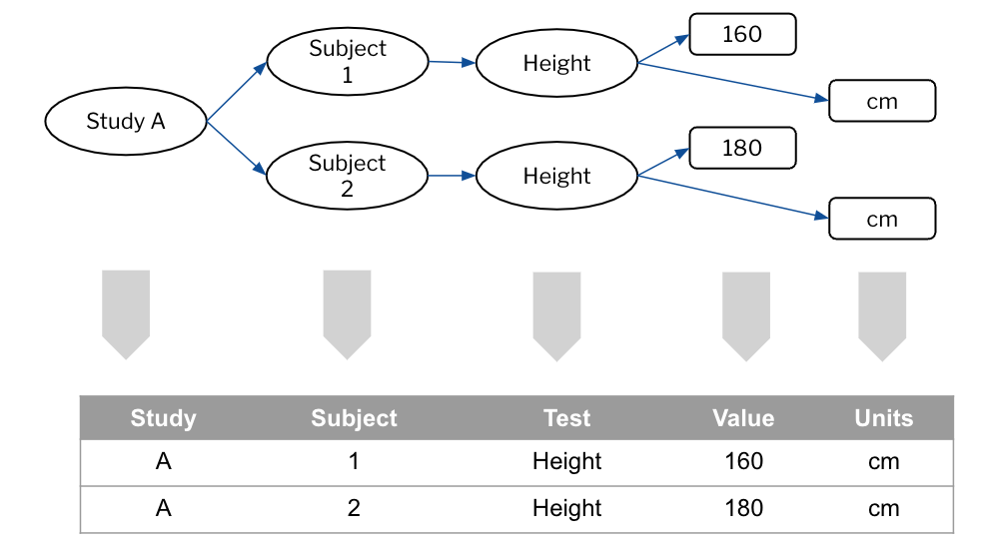

Figure 1 - Natural or Tabular Form

We need several items of data to be joined to form a single coherent “observation” with those items being related in specific ways. The value without the units is of little use. Without an identifier for the “observation” we have useless data. We need a certain number of items to form something useful and we need the context in which the data were collected, the subject, the study and so forth.

This has been recognized for many years. The FDA published the first Study Data Technical Conformance Guide [Ref 1] back in February of 2014. In Appendix A, you will find these words

*“A data value is by itself meaningless without additional information about the data (so called metadata). Metadata is often described as data about data. Metadata is structured information that describes, explains, or otherwise makes it easier to retrieve, use, or manage data. For example, the number 44 itself is meaningless without an association with Hematocrit. Hematocrit in this example is metadata that further describes the data.”*

Those words remain in the conformance guide to this day.

Going forward, as the industry encounters more complex data, there will be a need to handle the relationships therein. Geospatial and address data contain many attributes, and these are not rectangular!

The CDISC standards were developed in silos. This is not a criticism; it is just a fact of life. The problem space is a complex one and we, as humans, try to sub-divide that space to understand it. But by developing in silos, we have created silos in our data, and we lose the relationships across the boundaries and this causes us difficulties when we wish to automate [Ref 2]. We need a way to bridge those silos and, of course, the one item that bridges the silos is the data.

We want consistency in the data we capture to allow for the pooling of that data within sponsors and across industry. Currently this is hard to achieve. We should also recognize that our data can exist without the CDISC standards. I can measure my blood pressure so as to monitor my own health. A CDISC SDTM Vital Signs domain cannot exist without the necessary data. We want to be able to source the data for clinical research from multiple sources and allow for easy integration of such data. The data are independent from our human-enabled views of it. We need that independent data layer.

## Machine Readable

As well as the main reasons for considering the move to Biomedical Concepts, there are a set of secondary reasons behind pushing for their implementation.

The first is the need for machine readable metadata. While we can load the standards into the machine, we are not getting the level of precision that would help with better quality data and checking. An example would be code list subsets for a specified test code.

Providing precision for each observation would allow Therapeutic Area Users Guides, the TAUGs, to be defined as a set of machine-readable definitions with additional guidance documentation as to the use within studies.

There has always been the SDTM question of “where do I put X” and the proliferation of supplemental qualifiers. By bringing precision to the BC model CDISC could provide tighter guidance for sponsors, as to how to add supplemental qualifiers, when they are needed, while also allowing such additions to be readily recognized.

And all these factors add to the ability to automate tasks across the study lifecycle.

## Principles

To meet the needs outlined above BCs should be:

1. **Independent.** Each BC should be independent of the existing CDISC standards. A BC definition should not refer to any existing CDISC standard other than Controlled Terminology (CT).
2. **Linkable.** A BC should be able to be linked with the current CDISC standards, but that link must be decoupled from the BC itself. We want links to existing standards for the purposes of automation, but the BCs should be able to stand alone. Additionally, the BCs will be less likely to change than the views of the data such as SDTM and will allow for new standards to be developed more rapidly.
3. **Addressable.** Each observation should be uniquely identified and versioned such that I could use a single BC independently, each BC is addressable in its own right.
4. **Complete.** A BC definition should be complete, have all the necessary definitions such that it can be used directly, e.g. terminology references.

## Summary

1. Relationships
   1. Move away from views of the data to the natural form of the data and complete relationships within the data
   2. Silos and missing relationships
   3. The data and the current CDISC standards are independent
   4. Quality and consistency
2. Machine Readable
   1. Therapeutic Areas
   2. Help industry with better “mapping” guidance
   3. Automation
3. Principles
   1. Independent, linkable, addressable, and complete

# The Biomedical Concept Layer

As outlined in the previous chapter, a significant issue with the standards is their siloed nature. Across the current standards, we find that individual atomic data items, the variables, are replicated. This results in a need to map from the equivalent items when moving data across the silos. There is also a danger that one standard changes its definition while the others do not and we are being forced into unnecessary extra work.

A simple example is the notion of age. In a protocol we specify that we require the collection of Age. In the collection phase (CDASH) this gets standardised as AGE and AGEU. We then repeat the same definition in tabulations and SDTM which is then again repeated for ADaM and the analysis step. This is illustrated in Figure 2 below.

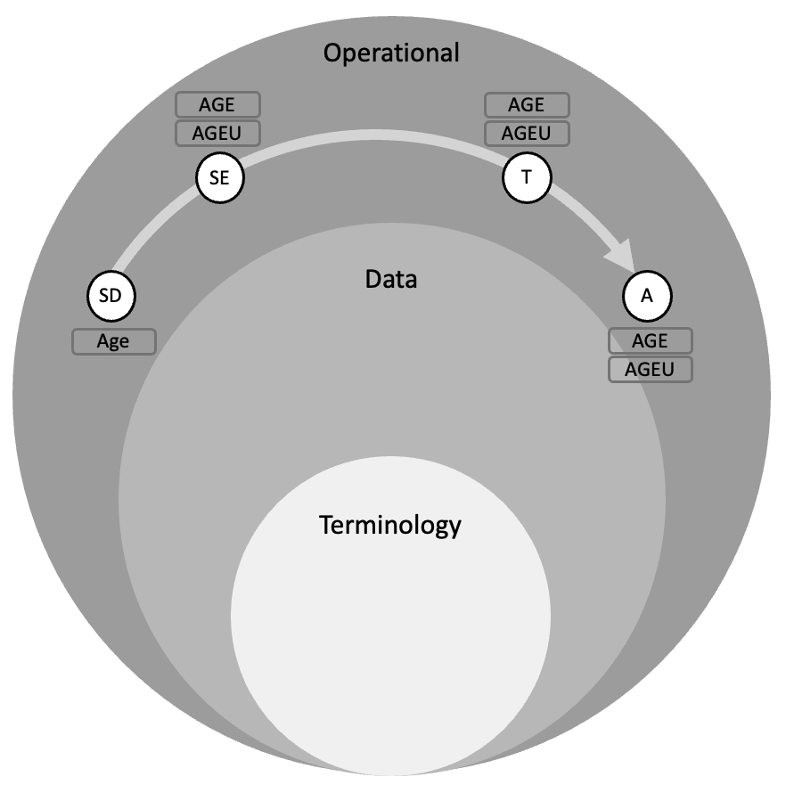

Figure - Repeated Definitions

Within Figure 2-1 SD = Study Design, SE = Study Execution, T = Tabulation and A = Analysis

Another important issue with the standards depicted in the figure is we can see that we have few layers in our standards. We have the terminology layer and the operational standards (CDASH, SDTM, ADaM) layer but, effectively, everything is compressed into a single layer, the CDISC standard.

If an intermediate data layer is introduced [Ref 3] within which we define the BCs and define the standards based on those BC definitions, we can remove the silo effect. This is depicted in Figure 2-2. We define the unit of knowledge once and then reuse across the operational standards

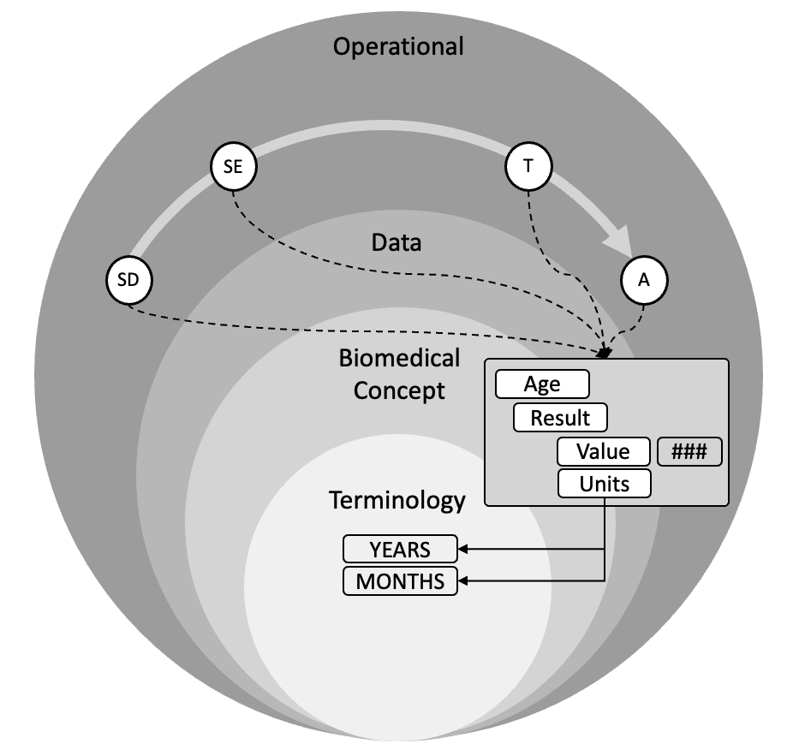

Figure - Introduce a BC Layer

As can be seen in Figure 3, the BCs refer to terminology while the operational standards refer to BCs, the “flow” of references is Standard -> BC -> Terminology and not the other way. Terminology knows nothing about the BCs and BCs know nothing about the standards. This is an important principle. The science does not change (the BC) but our standards may. It would also allow for multiple standards to be maintained for different use cases.

The BC becomes a new standard and is reusable across operational items, be they forms, domains, electronic data loads, wearables etc. The BC layer becomes future proof irrespective of technology as the definitions are based on the science of the observation, not the means of collection or subsequent tabulation or analysis.

A key benefit is that the relationships from the operational items allow a permanent link, or relationship, to be established between standards thus allowing for automation. This link removes the need for “mapping”. Automation brings consistency and improved data quality. This drives the requirement for a solid design to which BCs conform, such that the links / relationships can be formed.

The word “Mapping” is used widely within the industry; we seem to spend our lives constantly mapping. A definition for mapping that seems appropriate to the industry is

*an operation that associates each element of a given set (the domain) with one or more elements of a second set (the range).*

A mapping is a relationship and, we as an industry, need to map because the relationship is missing. This is an important point; mapping implies we have not defined something up front.

We need to define these relationships and not be restricted to simplistic 1 to 1 relationship such as the use of variable names. We need to ensure those relationships are there from the start, remove the need for “mapping” and enable automation.

The BC, the unit of knowledge, becomes the “glue” between the standards. Figure 4 illustrates this point with the example of a form and a SDTM domain. Here we would normally annotate the CRF with SDTM annotations, be it a PDF or some electronic form, and then perform the mapping in code because we do not have those relationships within the machine. Now we can use the links from the form to the BC onwards to the domain to allow the machine to do the work for us.

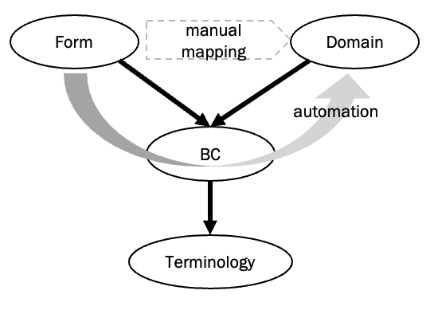

Figure - BC as the Glue

However, we need to be careful. Care must be taken so as not to disrupt our current world; we need to preserve what we have; BCs and our existing world need to work side-by-side. We should, however, remove the “wrinkles”, those elements of the standards that are not working, don’t fit the pattern etc.

With the introduction of the BC layer, we can now begin to see our world structured as a series of sub-models and layers. In Figure 5, this has been drawn with the operational elements across the top from Protocol and Study Design on the left through to Analysis on the right. Below is the BC layer with references from the operational layer to the BC layer. The BC layer then refers down to the Terminology Layer.

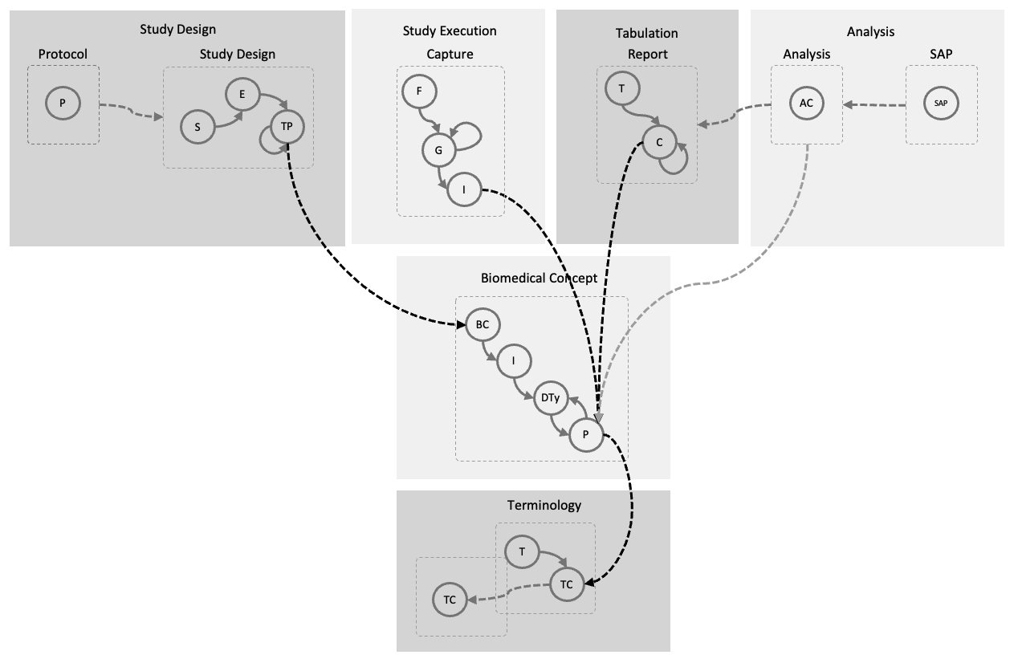

Figure - The Layers

## Summary

1. Relate our standards to a consistent view of the data
2. Remove silos by using the BCs to link across them
3. A consistent design for BCs to allow for the automation
4. Layered approach: Standards -> BCs -> Terminology

# Prototype

## Overview

It was initially intended to write a pure theoretical document on the design and use of BCs, but it became apparent from comments on the early drafts that readers would benefit from a prototype implementation.

Consequently, from the third draft onwards the document and the prototype work will progress in parallel and extra sections inserted into the document to reflect the prototype and note key features and lessons learnt.

## Prototype Structure

The prototype work is built from the following components:

* Neo4j Aura database running in the cloud. Two instances are used
  + Production - For the latest working demonstration
  + Test - For development work, such that a demonstration is always available on the production server
* A Jupyter notebook using the Google Colabs environment. This contains a script that loads all of the data needed for the prototype. It is intended that the order of the script should reflect this document, but it may not be a total one-to-one reflection. The Jupyter script uses python and the python Neo4j driver.
* Neo4jDash, a no-code dashboard, that allows for easy visualisation and storytelling of the prototype.
* Offline python scripts that build load files used by the notebook script.

All the scripts are located within a GitHub library. Figure 6 below depicts the general arrangement.

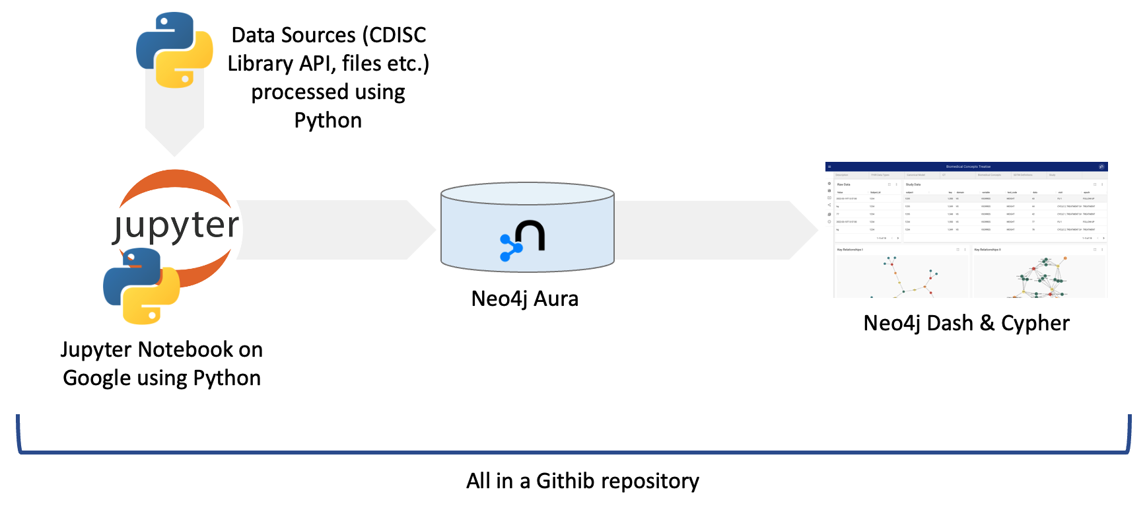

Figure - Prototype Setup

## Script Execution

The Jupyter script cleans the database at the start of its execution and rebuilds the prototype from the ground up.

## Linking

One feature of the prototype work is the need to, artificially, link nodes together.

An example is a BC and the CT used by that BC. In a real system this would be done either when the BC was initially designed, or the links would exist within some metadata library. The prototype is built from an empty database and thus there is a need to create such links. This is, as stated above, an artificial situation but is worth noting that such linking exists.

## Version

The prototype contains details of the various versions pushed in the Github repository. The prototype also notes the link between the prototype version and the version of this document.

## Dashboard

The prototype dashboard is designed to show the various components, how they relate and how the model fits together as a whole. It uses a series of tabs to focus on the major component parts with each tab having one or more panels containing a cypher query (the Neo4j query language) designed to illustrate some specific point and allow for the concept to be demonstrated and discussed.

## Github Repository

The demonstration software has been placed into a github repository that can be found at <https://github.com/data4knowledge/biomedical_concepts>

The software is licensed under the GNU General Public License v3.0.

# Design

## Overview

This chapter details the design of the BC, the BC templates needed to standardise BC content and a Canonical Model that drives the construction of the BC templates and enables the automation so desired by the industry. The Canonical Model is a key enabler that allows not only BCs to function but facilitates interoperability with other models.

## Initial Definition

We can start by providing an initial BC definition

*A Biomedical Concept is a computable specification of the data points of a single specific clinical recording excluding the context in which the recording was made. As such it is an atomic definition that is uniquely identified and addressable,*

## Context

As stated above a BC does not include the context of the recording. A BC is a recording that needs to be reusable in several circumstances. Obviously the main one is a clinical study but other contexts such as healthcare, public health are equally valid.

We also need to consider the relationships between the context needed and a BC. Typically, we wish to associate a recording with the person to whom it relates. But of course, there will be many recordings per person and that person can be viewed from one or more perspectives as noted above.

From these initial thoughts we can place the boundary between where BCs end and where other ideas or notions start. This is illustrated in Figure 7.

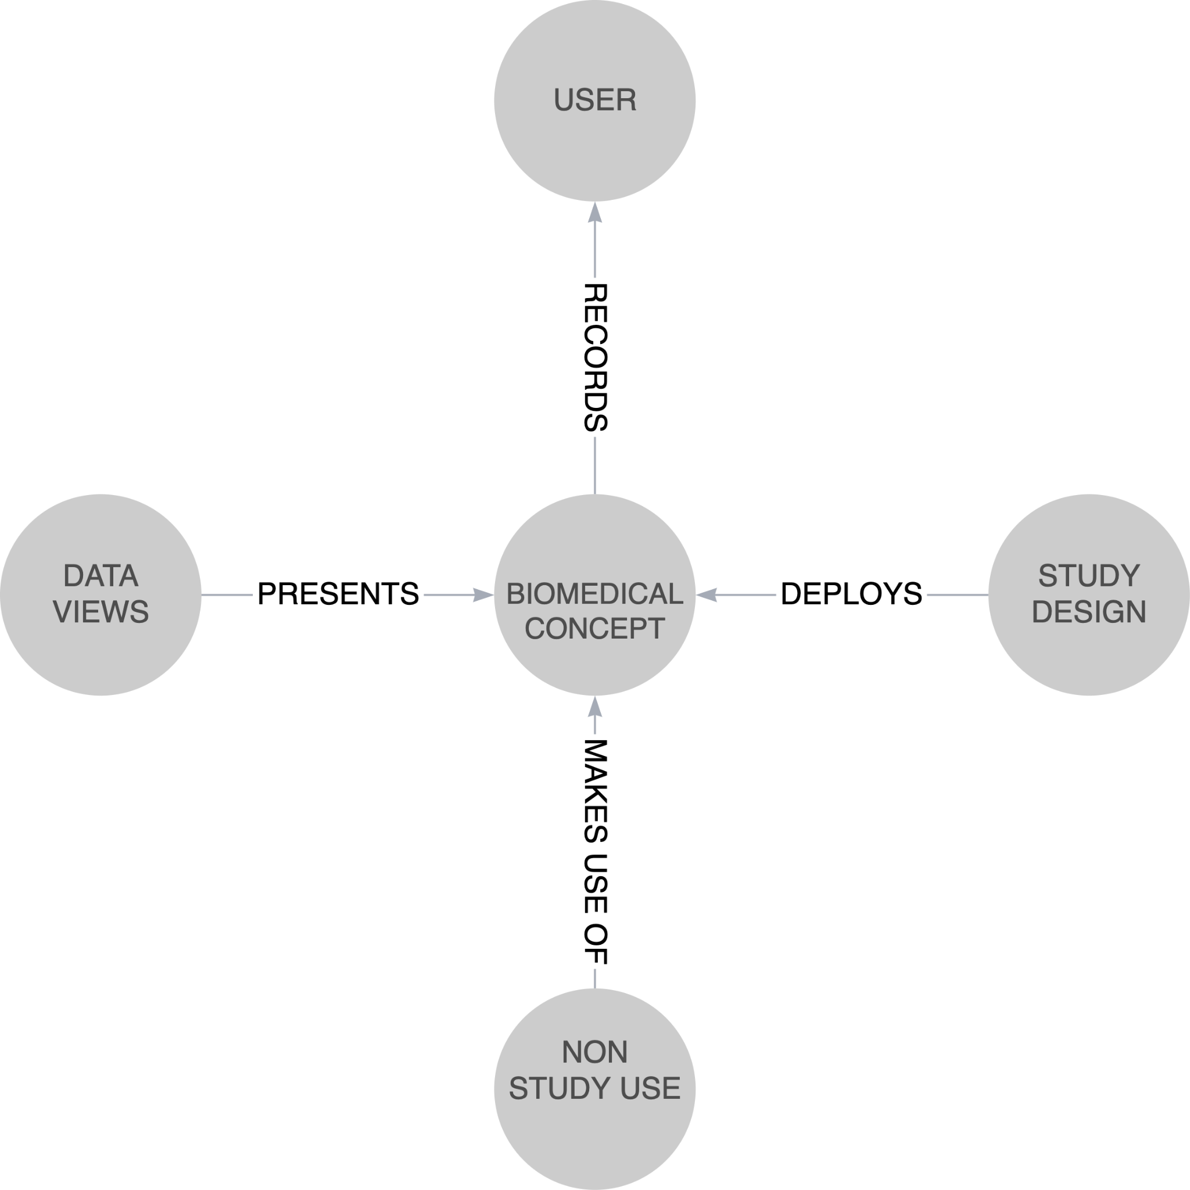

Figure - Context

## What is a Biomedical Concept?

BCs are models to structure the data resulting from a recording on a subject. At the most basic level we can consider a recording to consist of

1. Identification - a means of identifying the actual observation.
2. Result - the result. This may include a null flavour, a null flavour being an indication that the desired data are absent and the reason for it not having been collected.
3. Qualifiers - any further data that is needed to understand and qualify the result.
4. Timing - when the result occurred, be it a point or a range.

Additionally, we might add

1. Comments - Any comments noted at the time of capture.
2. Categorisation - Impose some classification on the observation.

At its most basic, A BC could be seen to be as depicted in Figure 8, an identifier, the result, the timing, and the qualifiers bound together as an addressable and indivisible piece of knowledge.

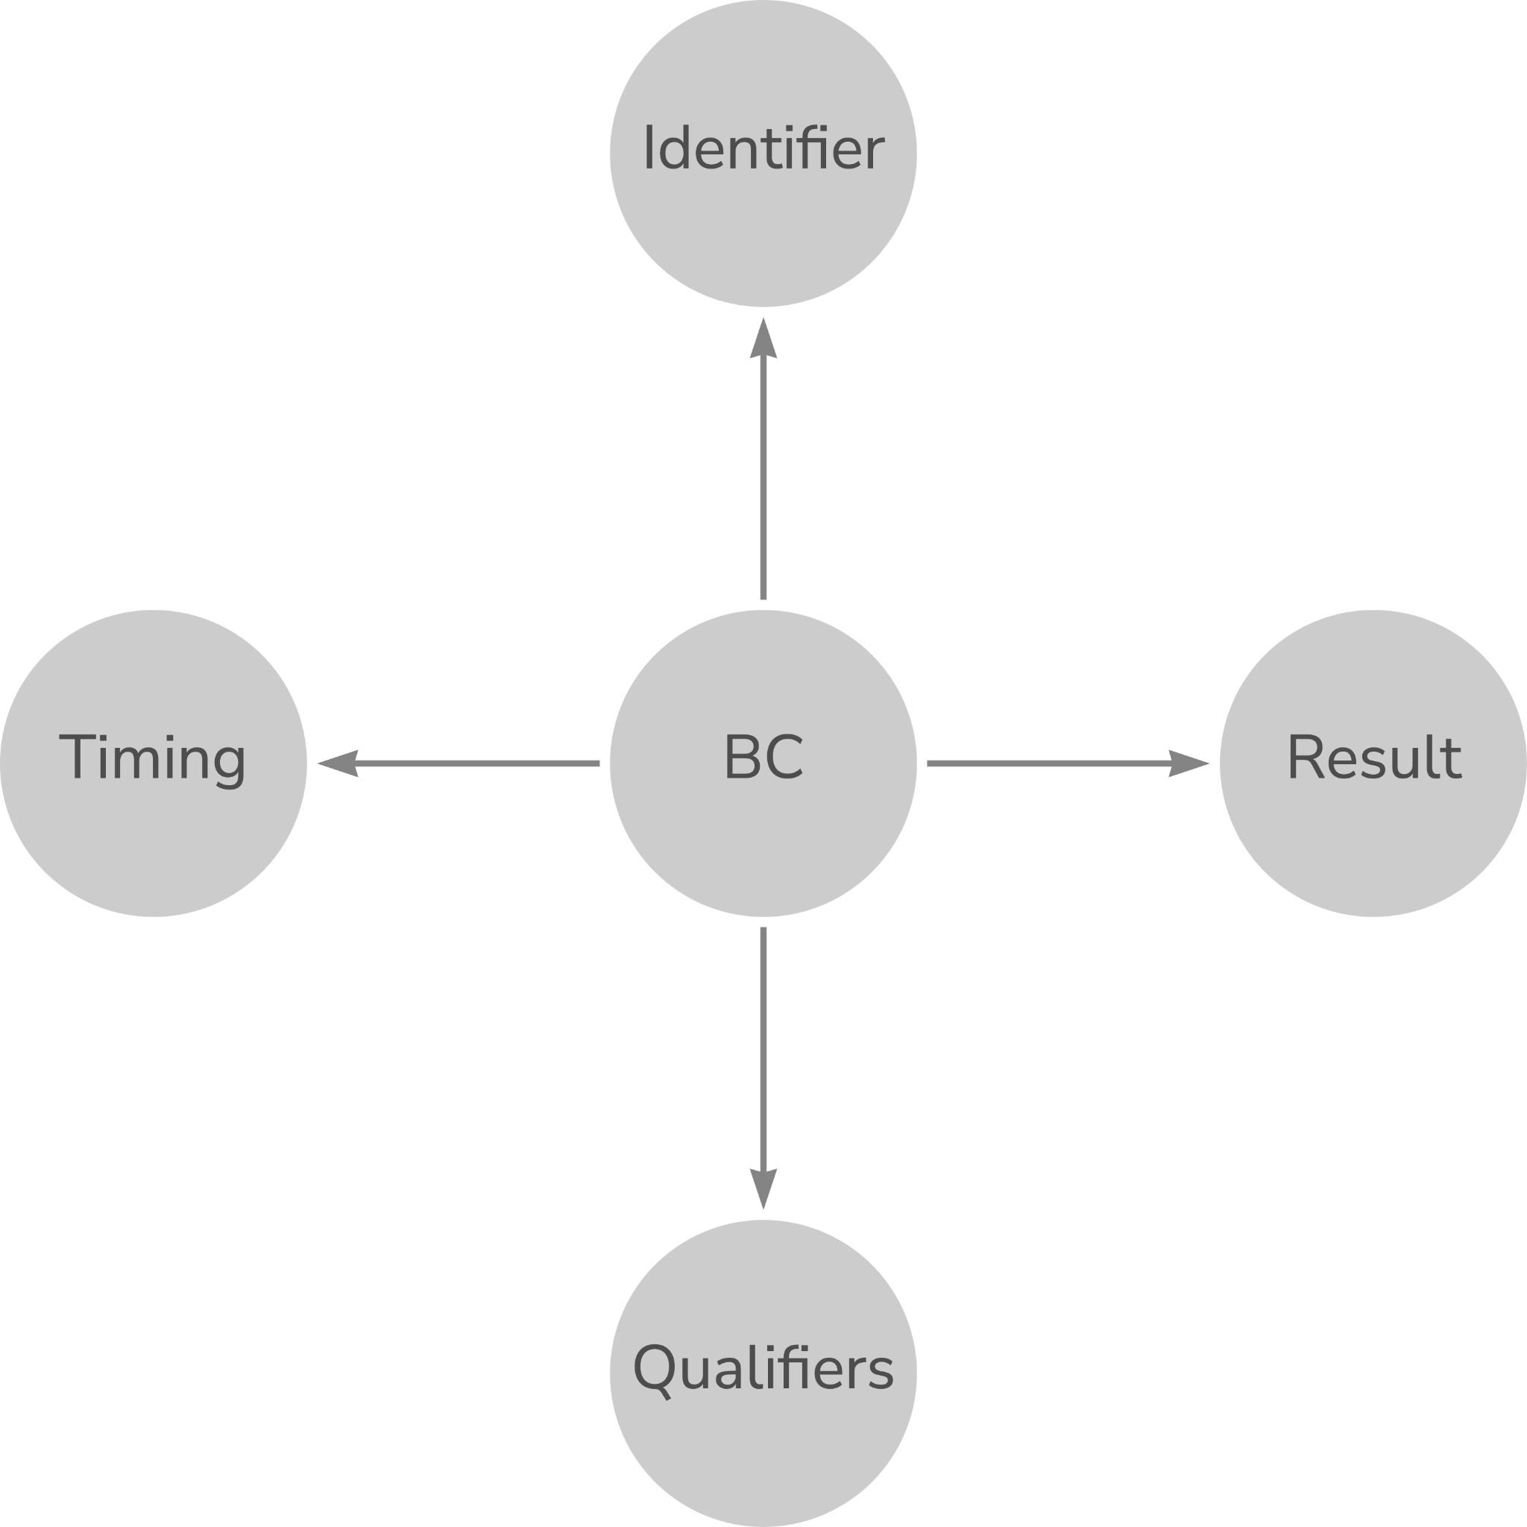

Figure - Simple Notion of a BC

Why do we want to draw such pictures? The answer is that if we understand the nature of the data we collect, the observations we make, we can better structure [model] our world. A clearer and more precise understanding will allow us to build the necessary relationships into our data from the start. As was noted earlier, if we have relationships from the start of the life cycle, we remove the need for mapping later in that same life cycle.

Over the last few years, Armando Oliva has been thinking about the nature of these observations and has documented his thinking in his blog [3]. Inspiration for what is presented below is based on his thoughts, as well as the current SDTM standard, experience, and various thinking and experience of use of BCs while putting the observations into the context of a study. Figure 9 is based on this combined experience.

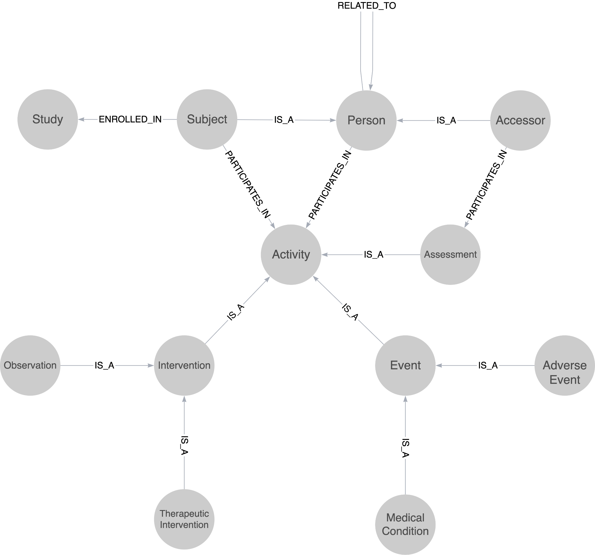

Figure - Context

Figure 9 leads to a different definition of a Biomedical Concept from the initial one presented earlier.

*A Biomedical Concept is the recording, in data, of a single activity within a clinical study*

Now this definition requires a definition of an activity within a clinical study but does provide for a shorter and crisper definition. Keen observers will also note that the above does not align with current SDTM thinking of Finding, Intervention and Events classes

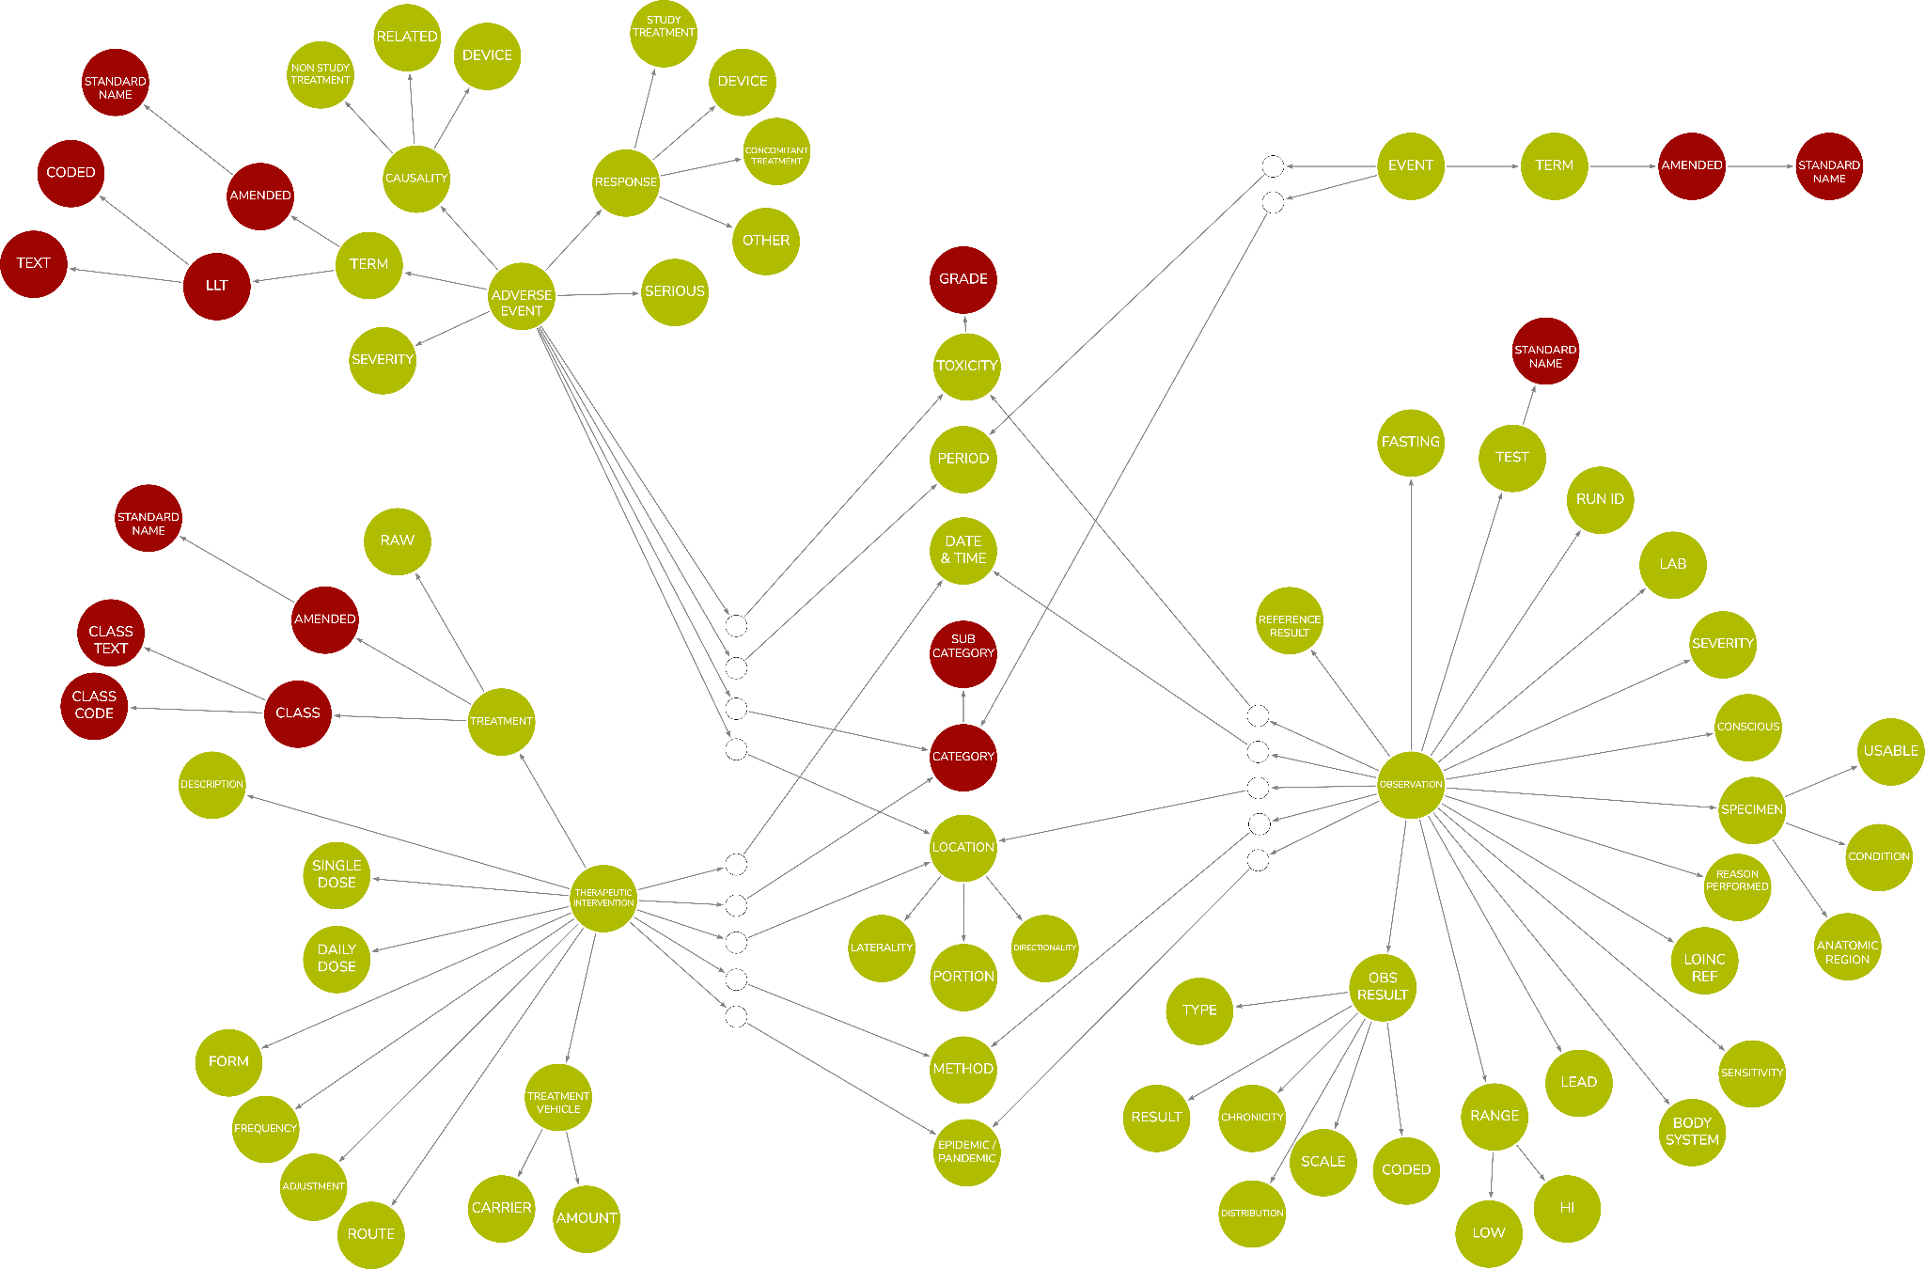

Figure - Canonical Model

*Note: Colour coding, red = derived data items.*

*Note: Assessment also needs to be added to the model*

The above model is preliminary, that should be stressed. Previous implementations have used a simpler Canonical Model, but it is believed that such a model will provide a more complete view of the recordings undertaken in clinical research. It needs further refinement and work but is included, as it provides a fundamental piece of the BC solution.

The above model details the set of data that make up recordings. Each leaf is a complex data type. Many are coded values, but others may be physical quantities, addresses or simple strings. A complex data type model is needed and HL7 provides such a model. The HL7 FHIR data types, see [5], offer a suitable model and would provide commonality with healthcare and not reinvent the wheel.

The combination of the model and the complex data types provides for a richness in relationships. Each leaf is intended to have a unique identifier that can be used to reference the unique concept: the value of a recording, the units related to that recording, a qualifier that specifies the method used to make that recording. The unique reference can then be used by any structure holding the data of the recordings to state “I am an X”. An X in another format can then be aligned or equated.. The hope is that the canonical model provides a means by which different data formats can be related and conversion automated.

Previous experience and implementations attempted to use the BRIDG model as the Canonical Model. This did not prove to be easy, as the BRIDG model is complex and use was sparse as we are only concerned with the data structure, not all the control structures found within the model.

This previous work also used ISO21090 data types, but the complex nature of the datatypes caused issues, as did the recursive nature of the definitions. The healthcare data types do work but a pragmatic approach does need to be taken, hence using the FHIR data types.

These models provide a canonical representation of our data and an understanding of the complexity of what we are recording and the relationships within those recordings. But why do we want this precision? This precision provides for:

1. A method by which we can define templates for our recordings so that we can bring consistency to our recordings across the industry and thus drive data quality and utility
2. A better understanding of our data in that we define up front, the structure of our data and the relationships inherent in our data.
3. Ability to extend our recordings to accommodate new science - new data - or to overcome operational issues - extra data - but doing so from a position of knowledge on the structure of our recordings such that we can do so in the best possible manner rather than a casual creation of another supplemental qualifier.
4. The canonical model will also provide a mechanism to link to other data models thus allowing for integration of other data sources into clinical research such as Real World Dtaa. This is exploited further in a later chapter.

## Biomedical Concept Model

### General

Given we now have the above canonical representations, we can now generate a model for a BC, a model that incorporates the ability to handle the recordings we wish to structure.

Many BCs will have a similar structure but there will be variations, for example, consider a basic vital signs test versus laboratory tests with the extra information that is captured. This gives a need to have a set of templates that:

1. Provide a consistent subset of the Canonical Model
2. Provide a more machine friendly structure and implementation
3. Provide the links from an instance of a BC to the Canonical Model
4. Make use of complex data types as not all our data is simple numeric values or a coded value set, some are complex such as geospatial data

The design used for the template and the actual concepts is the same, a concept reflects its template with the template providing the link to the Canonical Model.

The design is shown in Figure 11 below

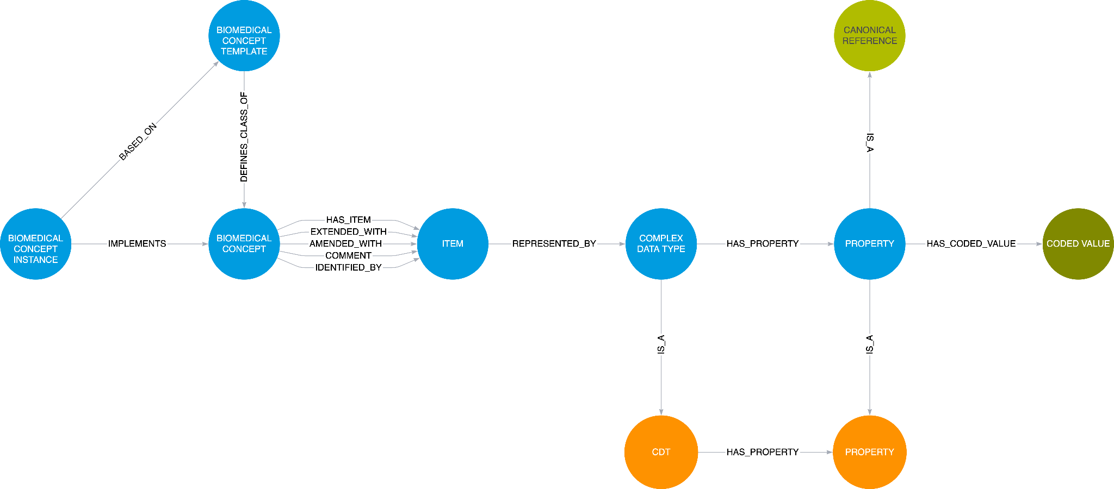

Figure - The BC Model

The model contains the template and the instance which both employ the core BC model. At the head of the model is a root node that binds the entire definition. A BC is composed of 1 or more Items with some of those items performing specific roles:

1. Identifier - The item that will identify the entire BC.
2. General Collection - The set of all items for the BC.
3. Comment - A comment item. The comment is global to the entire BC.
4. Extended - An item that is an extension to the BC. This is for planned additional data and should be reflected in the template prior to deployment.
5. Amended - An item that has been added to the BC during data collection. This is to allow for Ad Hoc extra data; a “get out of jail for free” card!

The model is based on experience of implementing several versions, from an early Excel-based version to two graph-based versions. It is expected to evolve, as people become familiar, and ideas improve.

### BC Template

The BC Template holds a pattern for a particular type of recording, a basic observation, a general lab test, a specific type of lab test etc. It is expected that there will be 10s of templates, but templates can be defined at any time. Such a definition should be version managed thus allowing changes.

The template is there to define the set of items within a BC and the data types associated with those items. A template does not define any content but defines the structure of a set of instances.

An item may be able to have more than one result data type, it may be coded, a value and units, free text. Templates must be able to accommodate this and allow for the selection when a BC instance is constructed. Using vital signs again as an example, consider a simple template that must accommodate Height with a quantity result versus Frame Size with a coded result.

Results may also be complex structures, such as addresses, geo data etc. This is one major advantage of a BC representation; we are not constrained by a rectangular form and can thus have greater freedom to represent the data we record accurately.

The following figure depicts a BC template, albeit simplified to reduce the number of items in use to make the figure readable. Each item is linked to a leaf in the Canonical representation via a complex data type.

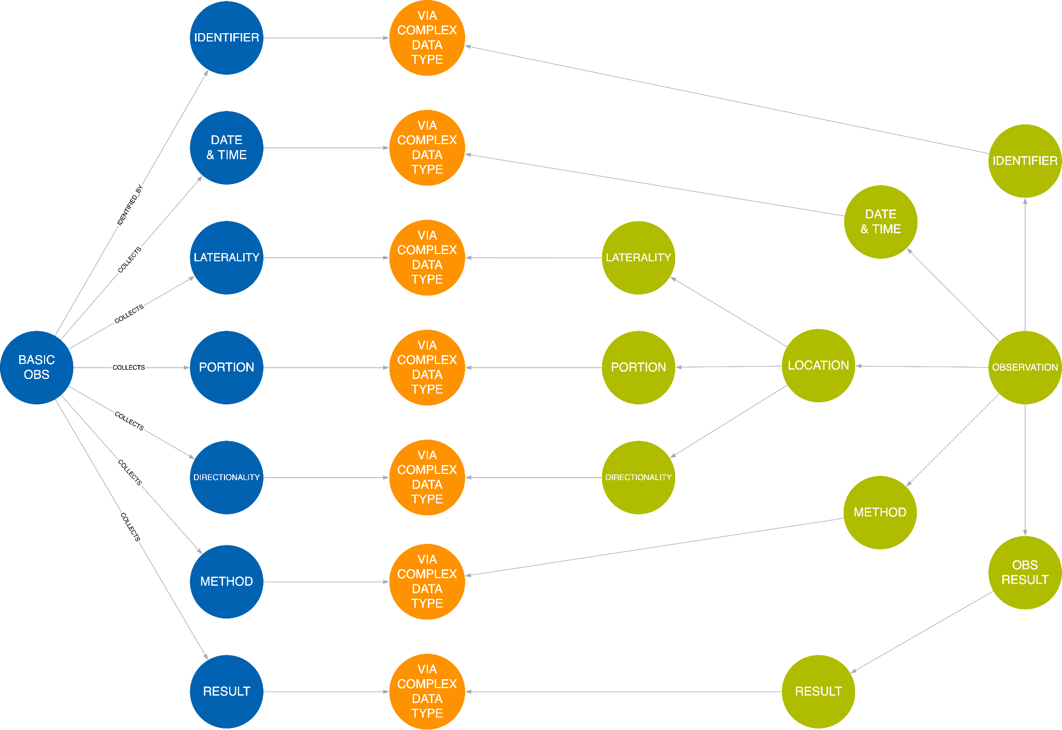

Figure - Example Template

One item is expanded to show the action of the Complex Data Type and how it is used by both the template and the canonical representation with each leaf being connected to the appropriate matching leaf.

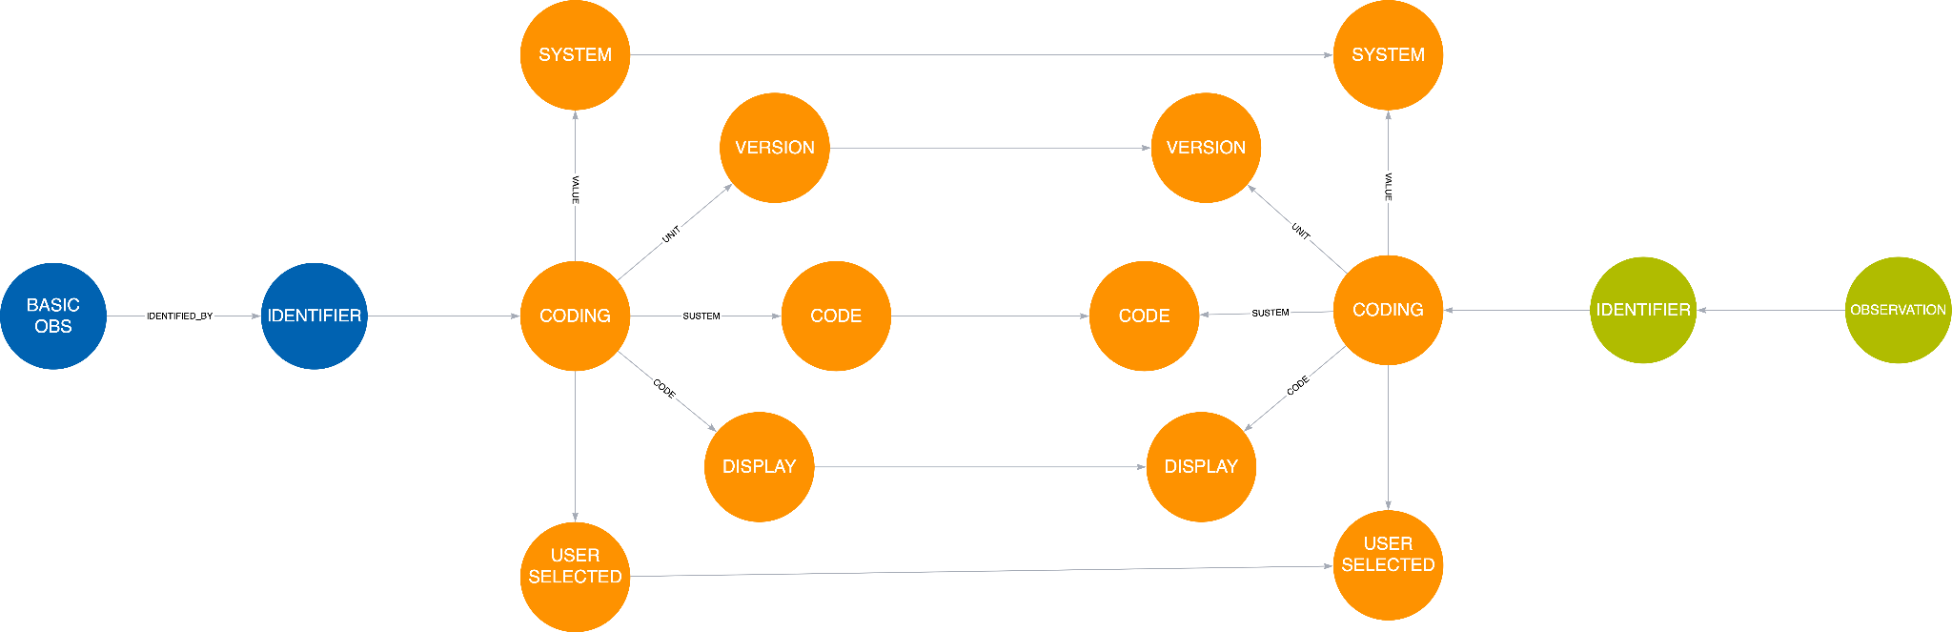

Figure - Expanded Item

One important concept to note is that each leaf on the canonical side can be referenced by multiple templates, there is only one observation.identifier.coding.code reference in the Canonical Model, there may be many references to it.

Reiterating a point from earlier. This may look complex and in some ways it is but we should not shy away from complexity but embrace it. It should be remembered that each leaf in the canonical model is intended to have a unique reference. Thus the leaf of the BC template is simply quoting that reference, stating “I am an X”. That unique reference might be a URI, a GUID, the simple string we used in the previous paragraph “observation.identifier.coding.code”, as long as it is unique that is all we need for an implementation.

We now have a Canonical Model detailing an observation and BC Templates that have precise relationships with that model



Figure - Model Overview

### BC Instance

A BC Instance holds the precise definition of a single recording. The purpose of a single BC is to provide a detailed definition of a recording including terminology references. Such a definition should be version managed thus allowing changes.

A BC instance is based upon a template which is constrained to what is required. A template may define a method by which the recording was captured but the BC may not need the method to be recorded. Certain items, such as the identifier and the result, will always need to be defined and this drives the need for a template to define mandatory and optional items.

Below is a simple example modelling the CDISC Height BC. The BC has been simplified to illustrate the essential concepts to keep the figure readable. The BC is based upon a template and the structure of the BC instance follows the template. The BC Instance is linked to the template at two levels, at the topmost level where the instance is linked to the template and at the leaf level such that each data type property is linked from the instance to the template; one example is shown in the figure below for Date & Time. The BC instance also defines the terminology thus forming a complete definition of the observation.

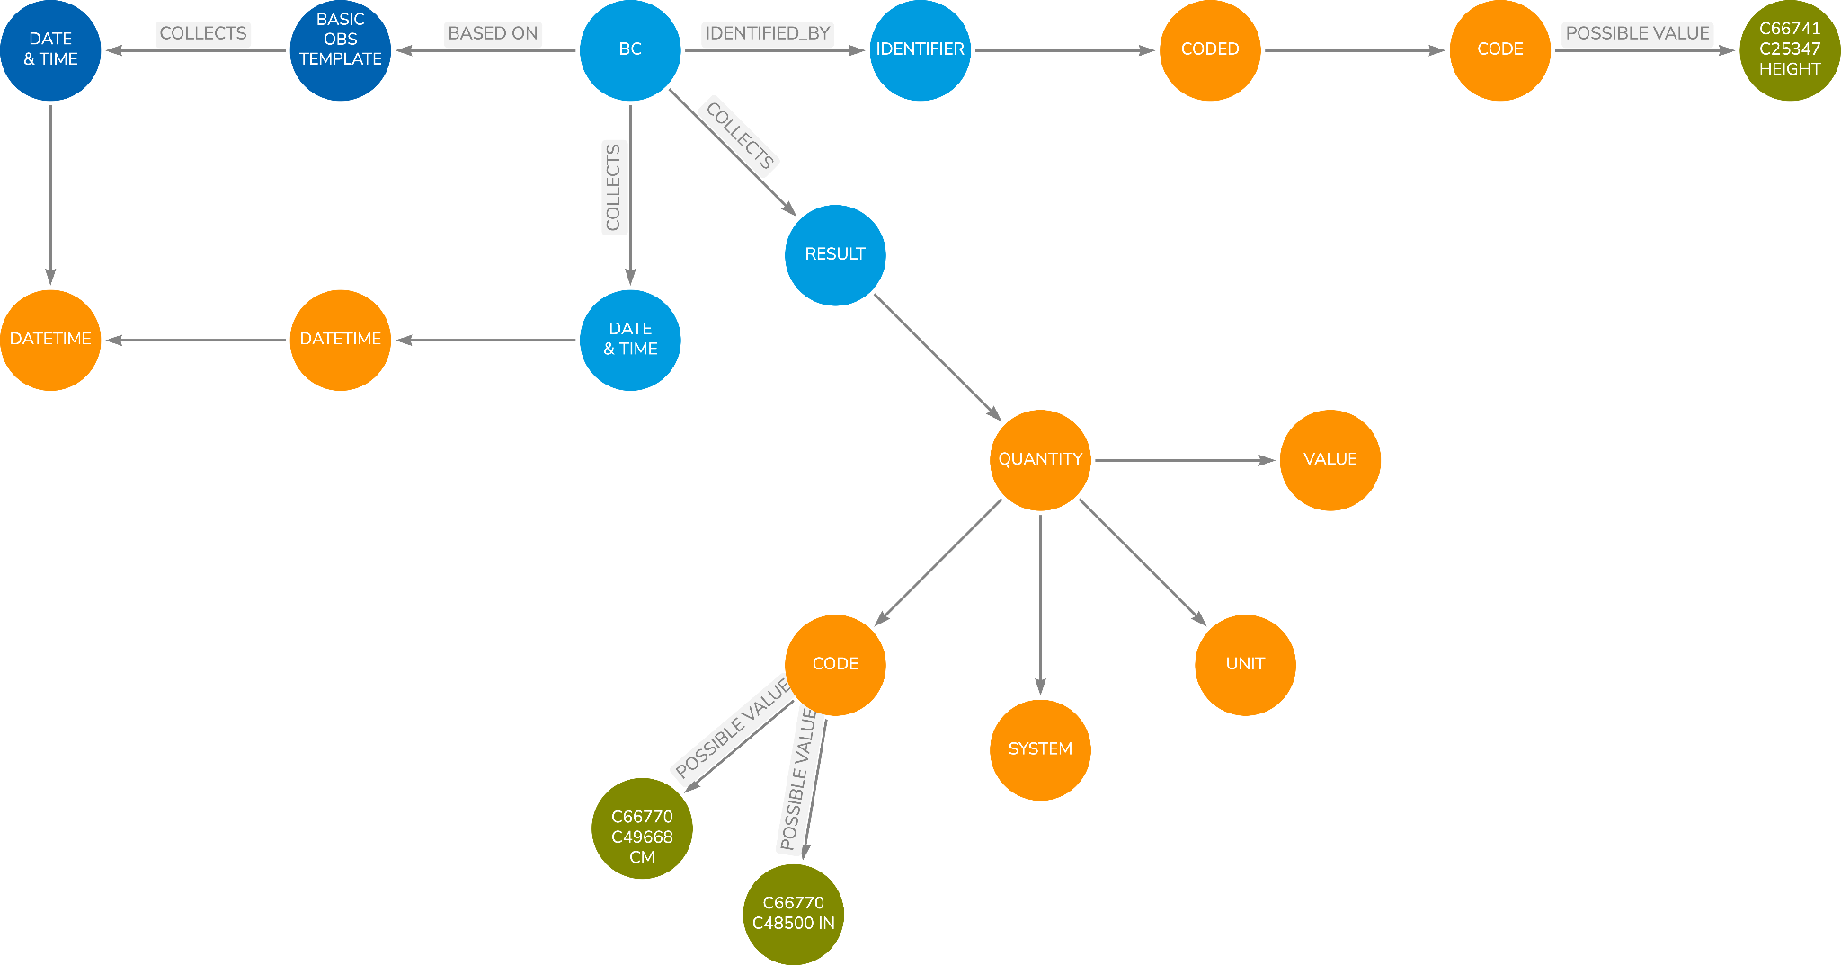

Figure - BC Instance Example

We now have a Canonical Model detailing an observation, the BC Templates that have precise relationships with that model and then BC instances formed from the templates. Note that, by linking the templates to the Canonical Model, the instances inherit the linking so that all the relationships in the canonical model are available to system processing BC instances.

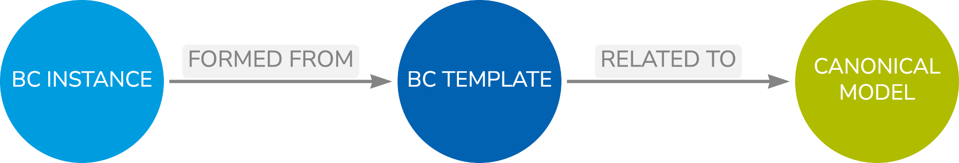

Figure - Model Overview

## 

## Collections

There will be a need to bring BCs together into collections. Collections may take several forms:

1. A collection of BCs that forms a higher-level BC or logical entity such as Blood Pressure formed from Systolic and Diastolic components.
2. Pre-determined sets of questions such as questionnaires or sub parts of a questionnaire.
3. Laboratory tests group into a panel or other such collection.
4. Forms but forms use several BCs to allow for the collection of data. CRFs are a very specific use case.
5. Tabular structures such as data transfer specifications where data content is passed from system to system

## Prototype Notes

### FHIR Data Types

Several of the simpler FHIR data types have been implemented and used across the works, such as within the BCs and the Canonical model. Types so far included are:

* Coding
* Quantity
* Date Time

The dashboard contains a FHIR Data Types tab that allows the data types and the associated properties to be viewed.

### Canonical Model

A draft canonical model has been included within the prototype. It must be stressed that this is very early work but is already displaying its utility. The model is based on the diagram included within this chapter, but this model requires significant work going forward. However, for the purposes of the prototype, it is sufficient, and the key concepts can be demonstrated.

The dashboard contains a tab to inspect the canonical model with several panels illustrating how the model is linked to the data types.

### BC Templates

Two templates have been created within the prototype: Base Observation and Base Laboratory. This is enough to accommodate the bulk of SDTM Findings type observations.

The dashboard contains various visualisations of the templates and the related relationships.

### BC Instances

Currently five base instances have been created within the prototype covering the VS and DM domains.

In addition, a single Glucose BC has been created and three specialisations based on the specimen type to illustrate how identification of such items can be achieved. Here the identification item has been linked to the clarifying property such that a unique BC is created, e.g. Glucose in Urine.

The dashboard contains various visualisations of the instances.

### Controlled Terminology

An issue was encountered when building the prototype in loading of the CDISC terminology. The size of the CT and loading the Aura Neo4j instance did not work so a workaround was employed. The workaround consists of a simple approach of loading just the Code Lists nodes and then loading the items for those Code Lists needed by a BC separately.

### Next Steps

The following features have yet to be demonstrated within the prototype:

* Need to prototype the ability to add extra items to extend a BC instance. This is to cover the case of a BC where some extra qualifier is needed and is added by a sponsor or other running a study prior to the study starting. This is a considered extension.
* Need to prototype the ad-hoc item extension for items added to overcome a study issue where a “quick fix” is needed.
* Collections. Need to demonstrate the collection of BCs ideas and how they could operate. This will probably need to be done within the context of a study.
* Supplemental qualifiers and how they relate to BCs needs to be demonstrated.

## Issues

* Need to incorporate the extra identification capability into the text above, extra relationships are needed within the design to reflect the prototype.
* Unused items in instances, should then be removed or “disabled”

## Summary

In summary, we have developed a BC template model linked to the canonical model from which we can develop individual BC instances.



Figure - Model Overview

1. Context
   1. The boundary of the BC in relation to the rest of the world
2. Canonical Model
   1. A generic model, applicable to clinical research, detailing the nature of the observations we make and the relationships inherent within our data
   2. Canonical model employs data types to manage the lower-level relationships
3. BC Templates
   1. Definition of the data items that form the key content of the observations we typically make
   2. Based on the Canonical Model thus inheriting the relationships and thus the knowledge
4. BC Instances
   1. Precise definition of an individual recording.
   2. Complete terminology specification.
   3. Place data at the centre.
5. Independence, Structure and Precision
   1. BCs are totally unrelated to existing CDISC structures except for terminology.
   2. BCs are an improved structure for existing CDISC content and fill the gaps.
   3. BCs are precise.

# Linking to SDTM

## Overview

We now have a BC model connected to a canonical reference model. So, what is next?

SDTM is of primary importance to the industry as it is a major part of a regulatory submission. One major aim of BCs is to aid automation. So how do BCs help with SDTM and automation? This chapter will explain how we can link the BC and SDTM world to allow for that automation.

## SDTM and BCs

SDTM is a combination of three types of data: a) the raw data as collected, b) data derived from that collected raw data and c) a set of timing information derived from the raw data and the study design.

The BCs are designed to better structure the raw captured data and thus the linkage between BCs and SDTM only concerns the raw data fields. The mechanism for linking the SDTM to the BCs is via the Canonical Model. This decouples the BC world from the SDTM world and allows for development to proceed on either without a ripple effect when one or the other changes.

SDTM is simply a rectangular structure in which each column is an atomic data item. In essence, SDTM is the placing of the Canonical Model into a rectangular form with the addition of the derived and timing data.

Consider the original result and units, these obviously map to the value and units in a quantity value or just to the result of a coded response as there are no units involved. The method maps to the coded response in the method item. We can simply link the variables in SDTM to the respective leaf nodes in the Canonical model.

So as to make the relationships as generic as possible, it is sensible to link the SDTM classes and the variables therein to the Canonical Model. By doing this we increase the flexibility as the relationships can be inherited by the domains and variables. This is the same notion as the BC templates linking to the Canonical Model.

The following figure shows a few examples to illustrate the relationships. Here --ORRES is linked to the various leaves in the Canonical Model that relate to an observation result. Obviously a result can be coded, could be a quantity and thus there are several routes available. The --METHOD variable is also linked but that is only ever a code value.

Note that the class variable definition is linked to the leaf data type node in the canonical model. Remember that the canonical leaf node has a unique reference, the same that is being used by the BC templates. Given that the BCs are also connected to the leaves of the Canonical Model we now have full linkage between BCs and the SDTM model simply through the use of the unique reference. Our world of knowledge and connectivity grows.

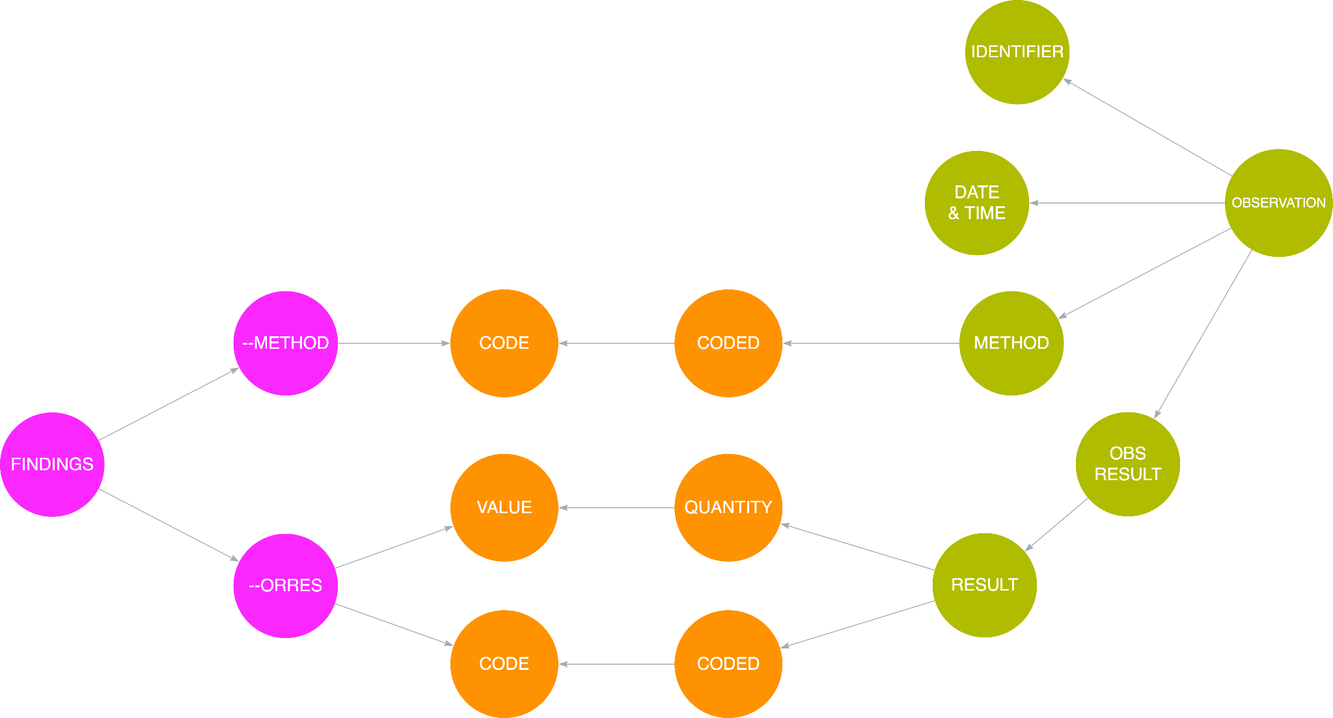

Figure - The SDTM Canonical Model Relationship

It should be noted that certain BCs and the templates will link to certain parts of the Canonical Model as will the SDTM models and this reflects the variation in our data. The templates will dictate what BCs can go to what classes within SDTM, but it should be noted that the BCs are linked to classes and not individual domains. That allows for a BC to be placed into many domains thus providing greater flexibility in the future. It also means we can allow a BC to be placed into multiple domains and the exact choice left to the study as to how best structure the data for the science.

We can also link all versions of the SDTM model to the Canonical Model and thus link the SDTM versions. This will be discussed further in later chapters, but this does facilitate automated conversion of data from older versions to a newer version of SDTM.

The linking of the Canonical Model to SDTM means that we have also, effectively, added more relationships into the SDTM model, those of the canonical model, that a machine can understand without disrupting the current SDTM model.

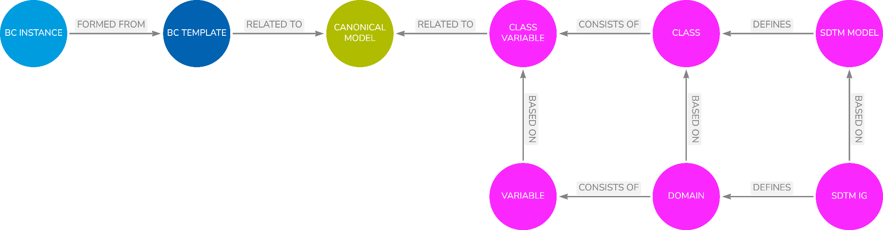

Figure - Model Overview

## Prototype Notes

### General

So as to demonstrate the principles of the linking of the SDTM model with the canonical model a small selection of variables has been linked. Examples for each of the SDTM classes have been chosen to illustrate the concepts.

### Findings

For findings the variables --ORRES, --ORRESU and --DTC have been linked to demonstrate the basic operation of the links between findings and the canonical model. This mechanism can be extended to any qualifier and such links will work in the exact same manner.

### Events

For the events domain --TERM and the timing variables --STDTC and --ENDTC have been mapped to the canonical model.

### Interventions

For interventions --TRT, --STDTC and --ENDTC have been mapped to the canonical model.

### Special

As an example of special domains DM has been used as an example. The variables AGE, AGEU, SEX, RACE and ETHNIC have been mapped to the canonical model.

### Dashboard

The “SDTM Model and IG” tab in the dashboard illustrates various aspects of the linking between the SDTM IG, the SDTM Model and the Canonical Model.

### Next Steps

1. Nothing significant planned

## Issues

As a result of linking the SDTM and a Canonical Model starts to expose a few questions and issues with SDTM. These include:

1. The use of --CAT and --SCAT variables and the desired use within domains. The use of these variables has been shown to be inconsistent and it maybe worth looking into best practice for them
2. The set of variables used to record when observations have not been captured during a study the reason for the failure to collect can be better modelled within the BCs, for example, with the use of null flavours. This better model can then be related to the existing variables.
3. Important flags such as fasting, clinical significance, epidemic / pandemic is another area where some better practice may be possible.
4. Comments, both at a BC level and an item level could also be improved using BCs and better mappings into SDTM be found.
5. One significant advantage of the approach is the addition of supplemental qualifiers. The Canonical Model offers the opportunity to provide better guidance to the community on the addition of Supp Quals and their addition to BCs and SDTM. With better visibility of a model SDTM practitioners will be less inclined to just add a Supp Qual in a haphazard manner but rather make more considered assessments of where a Supp Qual should be placed.

## Summary

1. The SDTM and the collected raw data is a rectangular form of the Canonical Model
2. By linking the SDTM to the Canonical Model we
   1. Add relationships to SDTM
   2. Link to BC Templates and thus BCs
   3. Decouple BCs and SDTM
   4. Provide flexibility into which BCs can be placed
   5. Allows for BCs and SDTM to have independent development paths
3. Once the SDTM model is linked to the Canonical model all BCs will be compatible with the SDTM, the model ensures compliance
4. Canonical model provides for much better understanding of SDTM and better decision making in the placement and use of Supplemental Qualifiers

# Protocols, BCs and Digital Data Flow

## Overview

This chapter details how BCs can be used as part of a protocol and linked to the corresponding study design such that the precise study data needs - the study data contract - can be formed. This study data contract can provide a precise and implementable specification for a clinical study.

## Study Design

A study design found within a study protocol document typically defines a design at several levels:

1. The arms and epochs which define the study cells (intersection of an arm and an epoch) which link to the elements (reusable cell content) and the intended treatments.
2. The Schedule of Assessments where high level design links to the intended visits and the procedures and assessments needed to prove, or otherwise, the scientific hypothesis being put forward
3. A further level of detail on from the SoA on the data to be collected

Currently, this is very much a paper exercise with protocols being delivered in a PDF form. Tools and designs are emerging that provide machine readable designs with Transcelerate’s Digital Data Flow (DDF) being at the forefront of such work. These initiatives address the higher two layers but have yet to provide industry with the models needed to provide a full, machine-readable design that provides a complete study data definition and the data contract.

BCs can assist with the lower level and when attached to the higher levels, can provide a complete study design definition.

## Protocol and Observations

Within many protocols we see examples of BCs without realising it. For example, we see text such as the following:

*Demographics … will be recorded*

*Visit 1:*

* *Age*
* *Sex*
* *Race*

Here Age, Sex and Race are BCs, units of knowledge that are composed of several parts that we dont really want to sub-divide. Another example is:

*Vital signs (Systolic Blood Pressure and Diastolic Blood Pressure, Heart Rate) ...*

Again, Systolic and Diastolic, Heart Rate are again, slightly more complex BCs but again BCs. In many Schedule of Activities we see footnotes listing observations to be undertaken at baseline visits and a subset of those BCs for subsequent visits. Again, these talk in terms of what are really BCs.

We also see collections of BCs referenced, such as:

* *“Blood chemistry includes measurement of …”*
* *“... standard haematology tests [including haemoglobin], blood chemistry tests [including LFTs] …”.*

The BCs are these observations referenced from within the protocol, either individually or as a collection. The references in the protocol are simply the meaningful, human readable, names of the BCs instances.

To build the detailed study design we need to provide a mechanism to link individual BCs or collections of BCs to the higher-level study design structures. If this is achieved then we can provide a complete study definition down to a detailed data level; we can build the study data contract, the data needed to prove, or otherwise, the hypothesis.

## Data At The Centre

The set of observations within the design, be they detailed individually or as a collection (e.g. a laboratory panel, a questionnaire etc), forms a precise Data Contract that needs to be met by the data collection process. The Data Contract is focused on the data, it is a data template, and does not care, yet, about the means of capture.

By building the data contract we place data at the centre [6]. We need to define the data contract irrespective of the data source. Some sources are important, such as validated instruments and patient reported outcomes, but laboratory data might arrive via a CRF or a tabular electronic data load, but the nature of collection is less important.

We are also splitting the data from the presentation, something we in clinical studies are very good at merging. The data are the data, how we collect those data is important for some of the content but much less so for the vast majority. Here the study design defines the data and we can move away from thinking about CRFs and the “how do I capture the data” to what the protocol should focus on and “what data is needed”.

## Endpoints and Objectives

In a Transcelerate document issued as part of the DDF Hackathon in November of 2019 appeared a paragraph. It linked the notion of Endpoints and BCs

*For example, using the TA Library for Asthma, a study in severe asthma could have as its Primary Objective “To evaluate the effect of drug x in participants with severe asthma.” The primary endpoints linked to this objective are limited to “absolute change in percent of predicted FEV1 from baseline to [Week X]” OR “increase [magnitude of change] in FEV1 from baseline to [Week X].” This also implies that the FEV1 biomedical concept will require spirometry assessments to be scheduled at baseline (CDM: primary timepoint) and week X visits (CDM: secondary timepoint), and that FEV1 measurements will need to be captured in the study database, either by EDC or via data transfer. Further, options for Secondary Objectives include FVC or FEV1/FVC ratio (spirometry), reduction in symptoms (questionnaire data) or fewer Clinical Exacerbations (medical history or diary data) or reduction in the use of rescue medication (diary, dosing device or medication count data). As each objective is chosen, the appropriate choice of linked assessments and measures would also be assembled in the tool using the latest available standards for that assessment.*

This highlights the linking of Endpoints, in this case a change from baseline to two instances of a BC, in this case FEV1. But what is interesting as well is not only the link from the protocol objectives and endpoints to BCs but also the connection to the timing aspects of the study.

This leads to a rethinking of the structure of a machine-readable design with the focus being placed on the timing aspects of the study.

## Timeline Approach

The DDF model provides a one solution to the study design issue and BCs can be linked to that design. This is the approach taken with the prototype implementation. This section outlines an alternative approach taking a approach based on a timeline.

The timeline approach is designed to represent the study more as a timeline reflecting the study high-level design while placing the timing information in a study into a single location within a model. All other entities that reflect the timing then refer to those centralised timing structures. This results in having a single source of study timing rather than spreading the information around the model in several places.

Consider Figure 19 below. The core of the model is a Time Point Node. This node represents a point in the study at which something needs to happen, either some data collection or a procedure(s) needs to be performed. Each Time Point is related to an Epoch, an Arm and a Visit such that its relationship with the high-level design is clear. However, the important timing information is maintained within the Time Point nodes thus keeping the timing in one place. The respective timings for a visit etc can be determined by inspecting (querying) the Time Point nodes.

*Walk through Figure 19 in the next draft.*

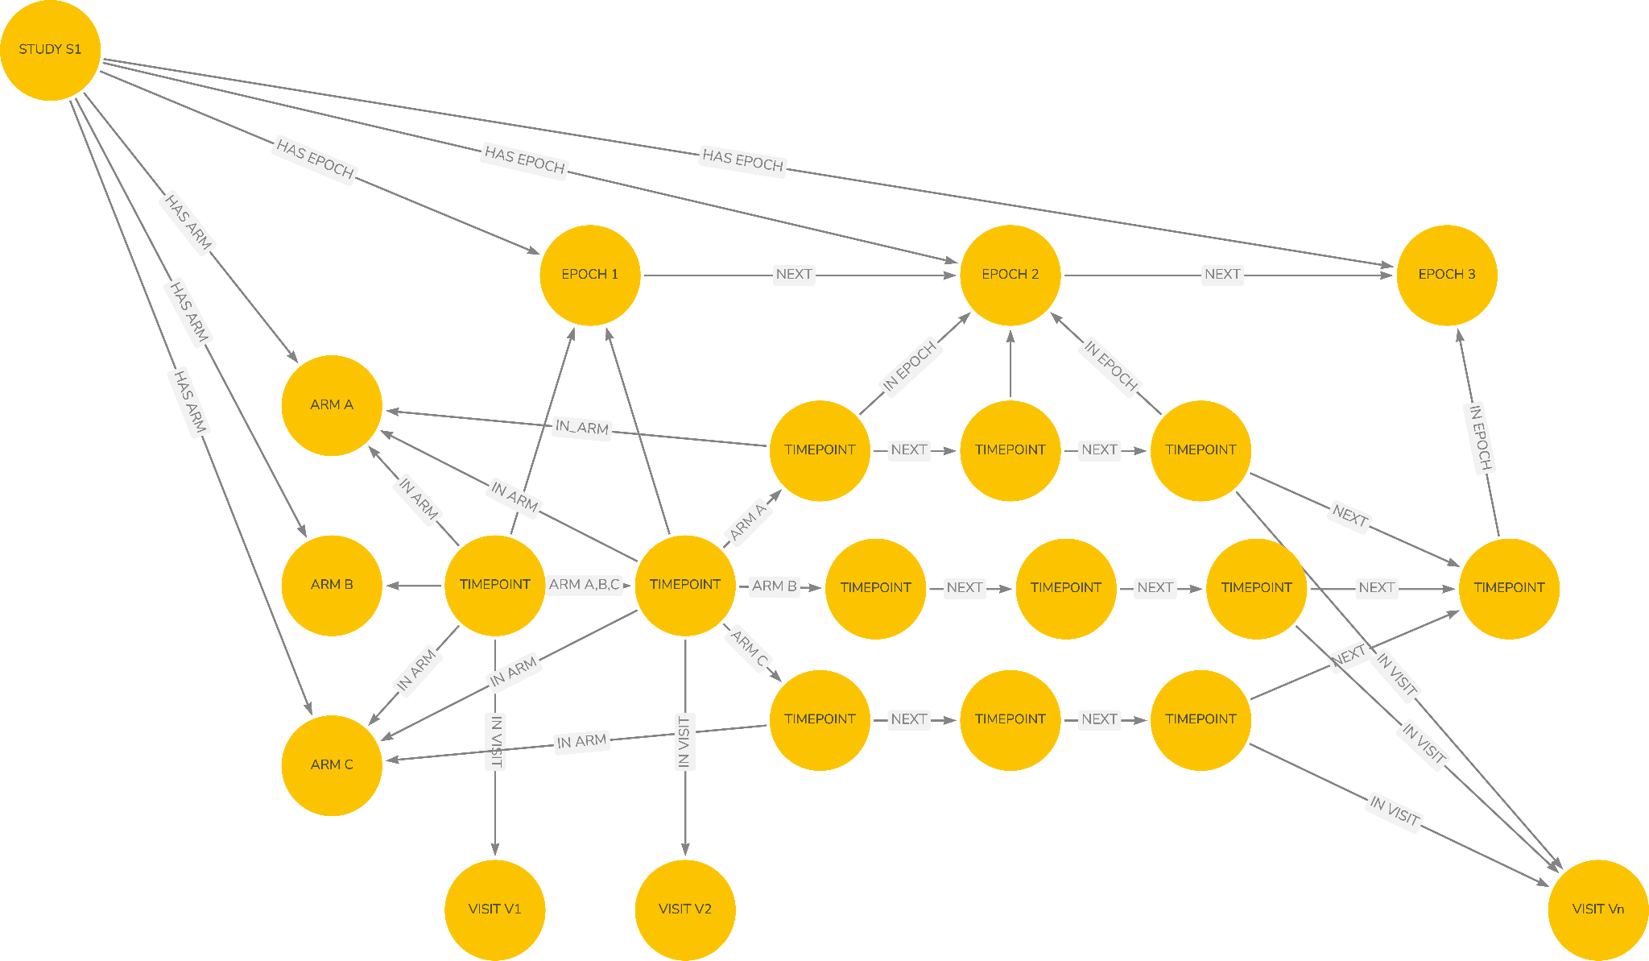

Figure - Study Design Using Timepoints

Figure 20 takes a closer look at a Time Point node and their relationship with each other. Each Time Point node defines the desired actions for that point in the study and links to the next Time Point. The links between Time Point nodes will require some timing and logic to determine what, if any, rules apply to the transition from one to the next. This allows for multiple paths and would also allow cycling back to earlier parts of the study if so desired.

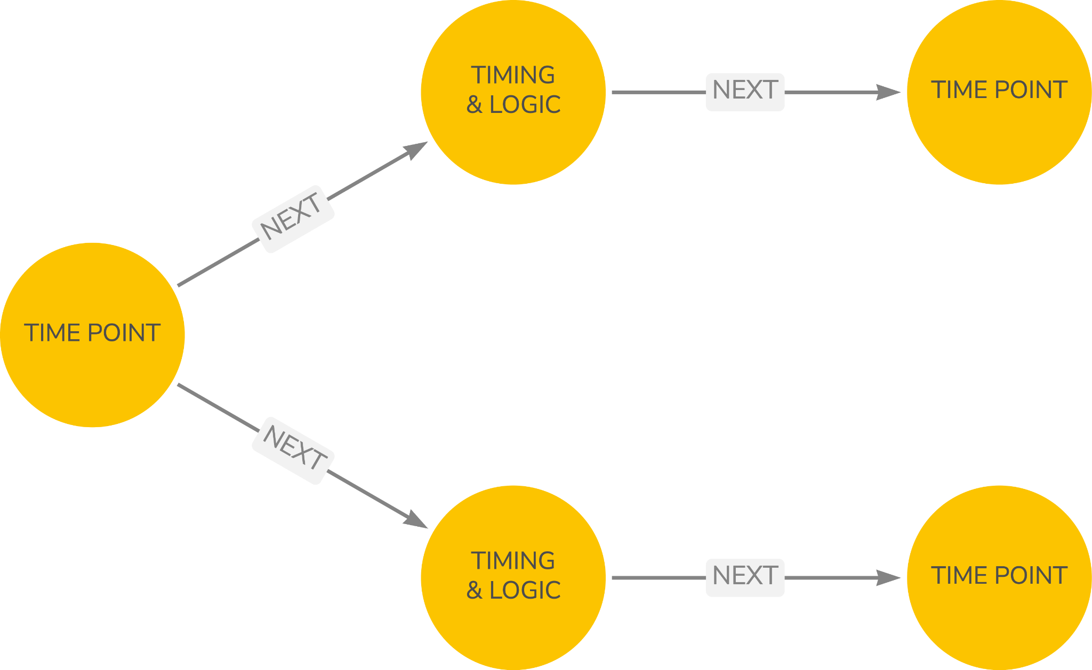

Figure - Time Point Logic

Figure 20 illustrates the specification of the actions required at each timepoint. This will consist of a sequence of BCs, collections of BCs (e.g., a laboratory panel) and Procedures required. If necessary, timing can be provided between the BCs, for example perform a procedure and then measure Heart Rate every 5 mins for 30 minutes, using the same type of logic as between Time Points.

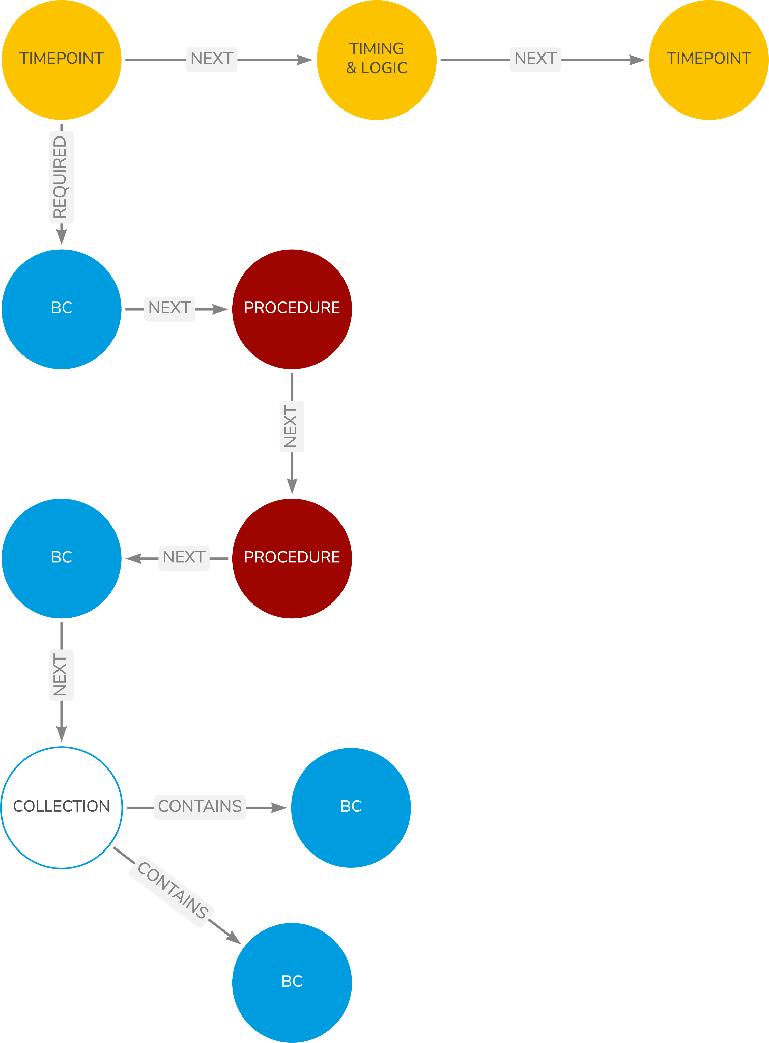

Figure - Time Points

We begin to see a structure emerge, a series of timepoints, able to reflect the epochs and arms within a study, linked to the arms, epochs and visits with each time point detailing the data contract for a study, be that a BC or collections thereof. This now provides the study design precision needed for automation in downstream systems. Figure 5-4 below illustrates several Time Point nodes each with the required data collection.

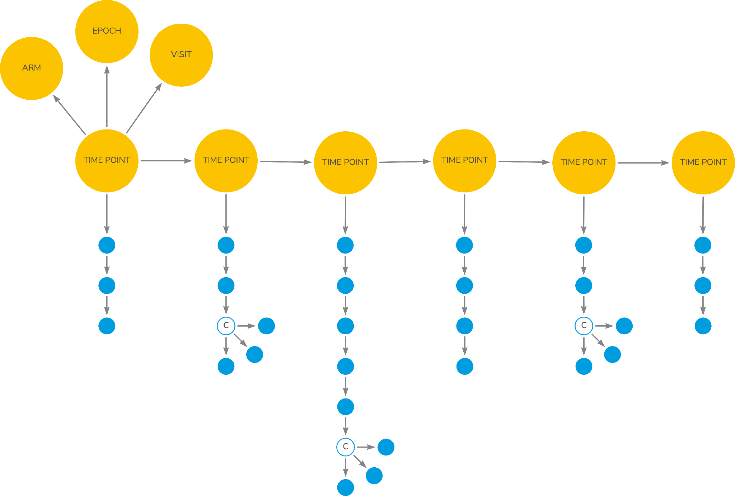

Figure - The Data Contract

Returning to the issue of endpoints, Figure 23 shows an endpoint linking to two BCs representing the change from baseline example noted earlier. This echoes the earlier comment about being able to add endpoints and associated data needs to the timeline but also suggests that other patterns such as safety data collection could also be candidates for adding to a timeline. Safety data, baseline visit requirements etc are just data patterns that can exist as a set of BCs with associated timing in the form of a data template. One or more patterns can be added to the study timeline: the objectives and endpoints, the safety needs, the subject data such as demographics.

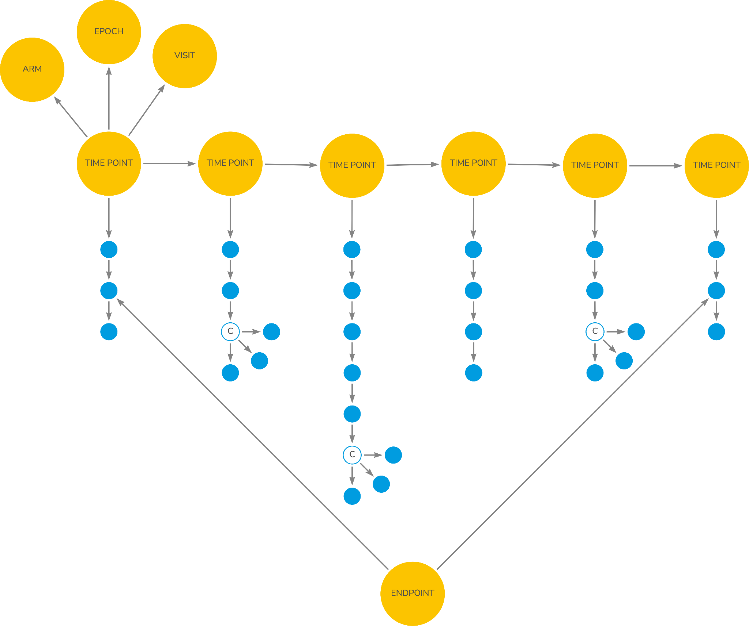

Figure - Endpoints

## Prototype Notes

The prototype implements a logical representation of the DDF model using a single study. To that design BCs have been linked. When a BC is linked to a study a copy is made as the study may further configure that BC. Such configuration might be to constrain the permitted units, the constraining of a method or the disabling of certain qualifiers altogether.

By creating a study BC each data point within the study design becomes a unique data point and can be allocated a unique identifier, for example, a URI. This is helpful for purposes such as FAIR data sharing.

## Issues

None currently noted.

## Summary

1. We need a study data design that results in a precise study data contract
2. Such a precise design allows for subsequent automation downstream
3. The data contract is a combination of BCs and the precise timing of when the data are to be collected
4. The study timeline is linked to the study Arms, Epochs and Visits.

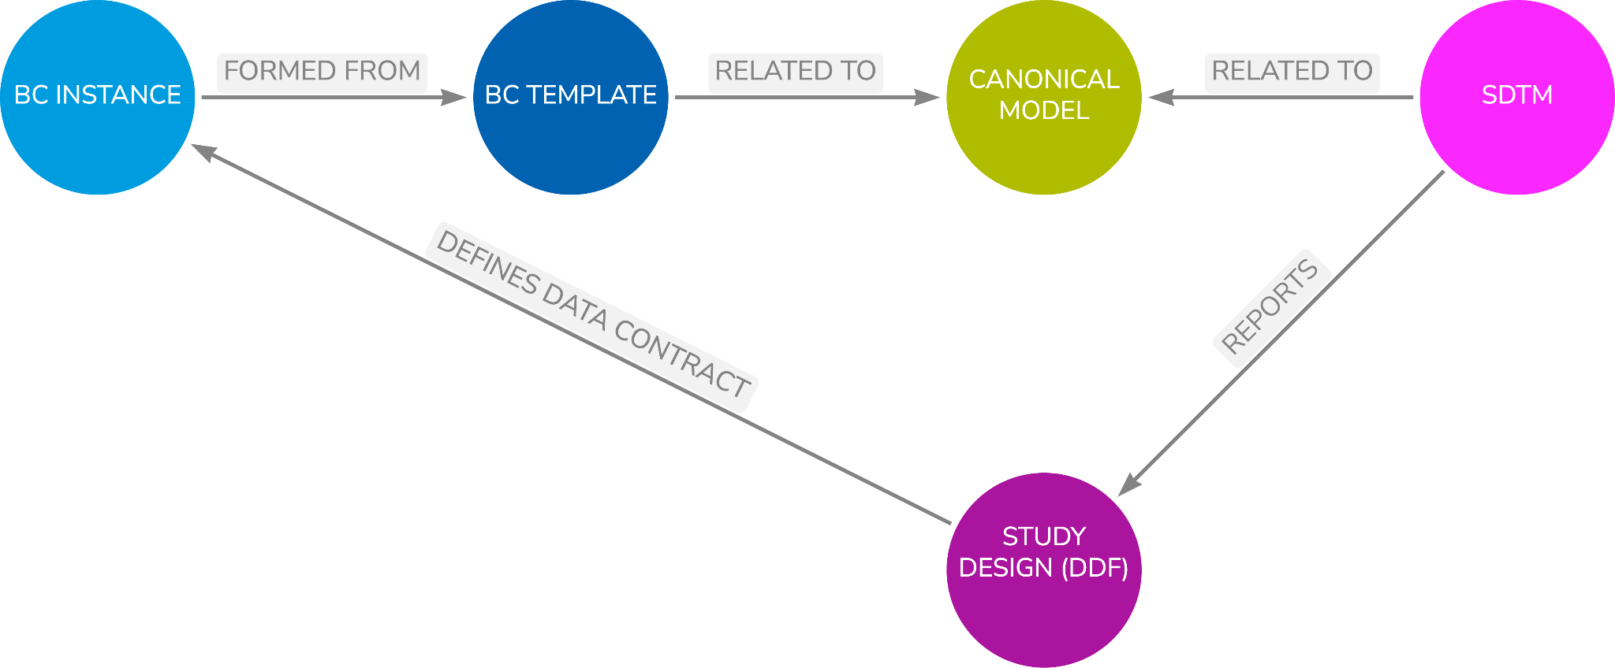

Figure - Model Overview

# Building Forms

## Overview

This chapter will detail how BCs can be used to create standard form definitions.

Much has been talked about standard CRFs since the first ACRO forms were put into an electronic form and the CDASH project was started by CDISC in 2006. BCs work at a data level and, as a result, if BCs are used consistently, the data collected becomes consistent. Consequently, the form becomes less important, the BCs ensure we standardise our data, the form is solely responsible for collecting high-quality data.

This then ripples to other types of data collection; we want other data collection mechanisms to focus on a stream of BCs and the data definition and less on how the data are collected. This then results in all our data streams sharing a common data definition and being allowed to focus on the issues of collecting high-quality data from the respective medium.

All that said, forms are important to the clinical research world and BCs can be used to build CRFs.

## Design

A form based on BCs can be represented using a simple model as shown in figure 6-1. A form can have one or more groups with a group being able to consist of sub-groups. This allows for a recursive structure. A group can consist of one or more items. This structure is very similar to the current CDISC Operational Data Model structure of ItemGroups and Items except for the recursive nature of the groups.

The items can take one of four forms, either an item from within a BC, a traditional question as we see of CRFs today, metadata for use in combination with traditional questions or a placeholder for those situations where information is incomplete.

BCs, when used on a form, provide several form items in a pre-packaged form. This allows for a “drag and drop” capability whereby a group can be created within a form, a BC can be added to the group and the items within the BC can be turned into items on the form using the BC metadata. This provides for a quick and easy way of creating forms while collecting consistent data as the same BC can be added to many forms. Only the “visible” items within the BC are needed on the form, those that need collecting. The other items, the metadata items are not added by the form but, of course, the form is linked to the BC and thus a full metadata definition is provided for subsequent processing, such as CRF annotation.

Groups should allow for a mix of BC items and traditional items allowing for full flexibility in the creation of forms and allow for a slow migration from a traditional question-based form to a BC based form.

One issue that is quickly encountered when working with BCs is when multiple BCs are added to a group within a form there will be common fields created, such as the date and time of collection or a body position. Most of the time the form should only display one field to capture such common data and thus the ability of a group to have a common group. This is used to bring the common items together and thus collect them once but link the data captured to the multiple items within each of the BCs.

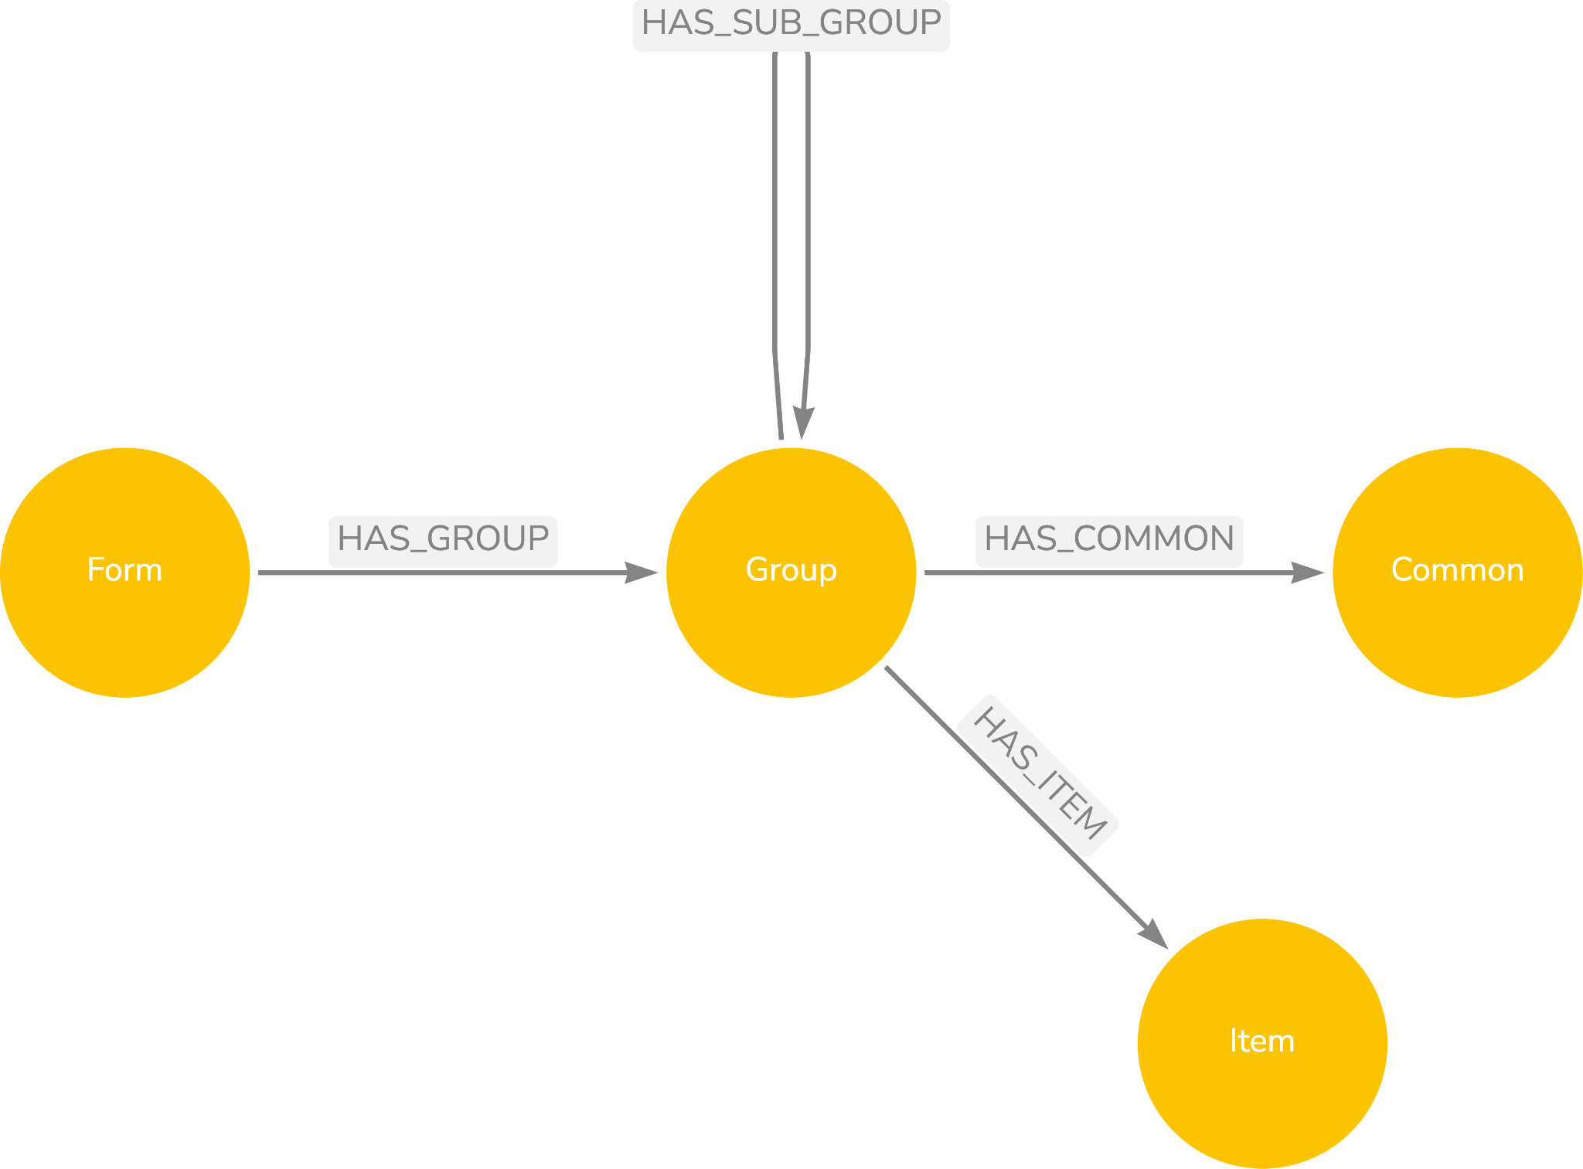

Figure - Form Design

The metadata items are there to allow for the provision of the extra metadata found in BCs that is not present in a traditional form, such as test code or qualifiers that have fixed values.

Previous experience has shown that the above design works well, allowing for forms containing rich metadata to be built that can be readily exported to EDC systems in an ODM form.

The linking of the form to the BC obviously links the form to the rest of the knowledge graph as shown in the figure below. We now have a path from a form through BCs to the SDTM and a link into the study design. It is the path from form to BC that allows for the auto annotation of individual CRF or entire study CRFs.

## Prototype Notes

### Overview

The prototype has not been developed extensively yet in this area as much work has been done in the past and has shown that forms and BCs work well together.

The current prototype implementation shows a simple form based on a simple mechanism whereby a group is created, several BCs added to the group and then the group visualised by converting it to an ODM XML form. The form is then rendered using an XML stylesheet.

A simple view of a form is included within the dashboard and a rendering is included within the Jupyter notebook but a more comprehensive demonstration is needed

### Next Steps

1. More comprehensive demo including common group handling.

## Issues

One of the issues with BCs when used on forms is where to define the question or prompt text. It is debatable if the text should be defined as part of the BC or at some other level. For questionnaires and similar instruments, it could well be argued that the text should be defined as part of the BC or as part of a wrapper around the BC when specificity is required.

## Summary

Forms can be built from BCs to allow for consistency of data capture across multiple forms and allows for a move away from standard forms to a focus on forms that are based on standard data, the BCs.

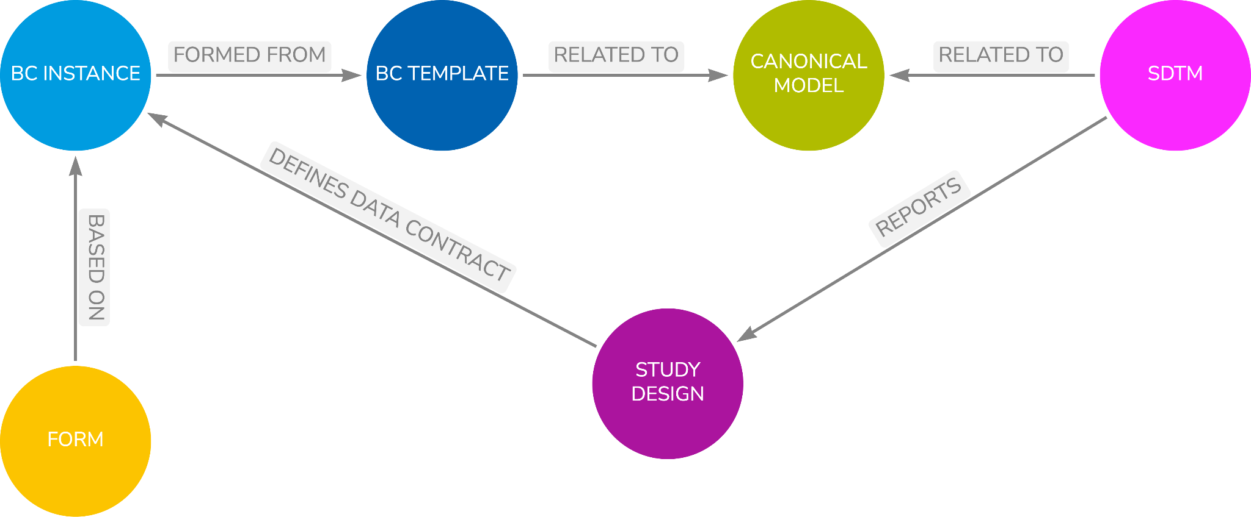

Figure - Model Overview

In summary:

1. Build forms from BCs to standardise the data captured rather than building standard forms that always seem to be modified.
2. Allow for a recursive structure within a form to allow for flexibility in structuring a form and mixing BCs and questions.
3. Allow for a mix of old and new allowing BCs and traditional questions to exist together within the same group or form thus allowing for forms to be slowly migrated to BCs.
4. Allow for metadata fields to provide the required metadata to allow questions to provide full definitions and equivalence to BCs to be created

# SDTM Generation

## Overview

This chapter details the mechanisms needed to provide for the automated generation of SDTM domains using captured data combined with metadata from a study design and BC definition.

The approach used is based on earlier work, see reference [4].

## Design

As stated earlier, SDTM domains are a combination of raw, collected data, data derived from the study design and data derived from those other two elements. Thus, to generate domains, raw data is required.

The desire is to have one integrated graph and, therefore, the approach taken is to link individual data points to two “anchors”. The anchors are:

1. The individual data point within the study design down that the data item releates. This will be a leaf node of a BC within the study design.
2. The subject to whom the data relates. The subject will be linked to the encompassing study and thus the design for the study.

Thus, the design necessary for data generation is as shown in Figure 27 below.

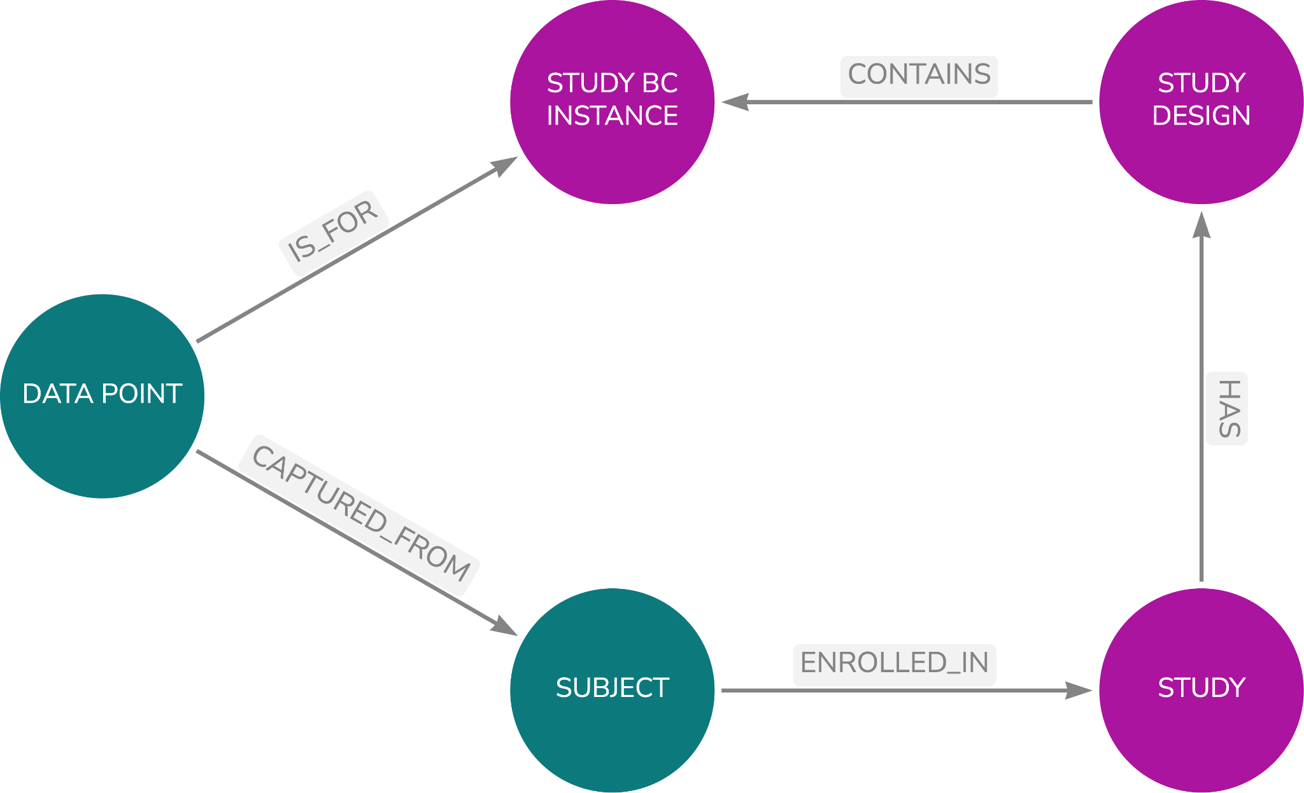

Figure - Linking a Data Point

This provides for a complete graph of a study design, the associated data, and links to operational standards such as SDTM, all combined into a single graph. Once the graph contains the first data point it can be queried such that SDTM domains can be generated.

The data that can be queried is obviously only the raw data plus the associated study design aspects such as Epoch and Visit. This provides a skeletal domain that requires the derived data to be added.

The derived data could be built away from the graph, but it is also possible to handle the derived fields as part of the graph. Each target derived variable can be linked to a set of nodes that define the processing to be performed to generate the value for that variable. This logic can then be used on the skeletal domains to generate the derived data.

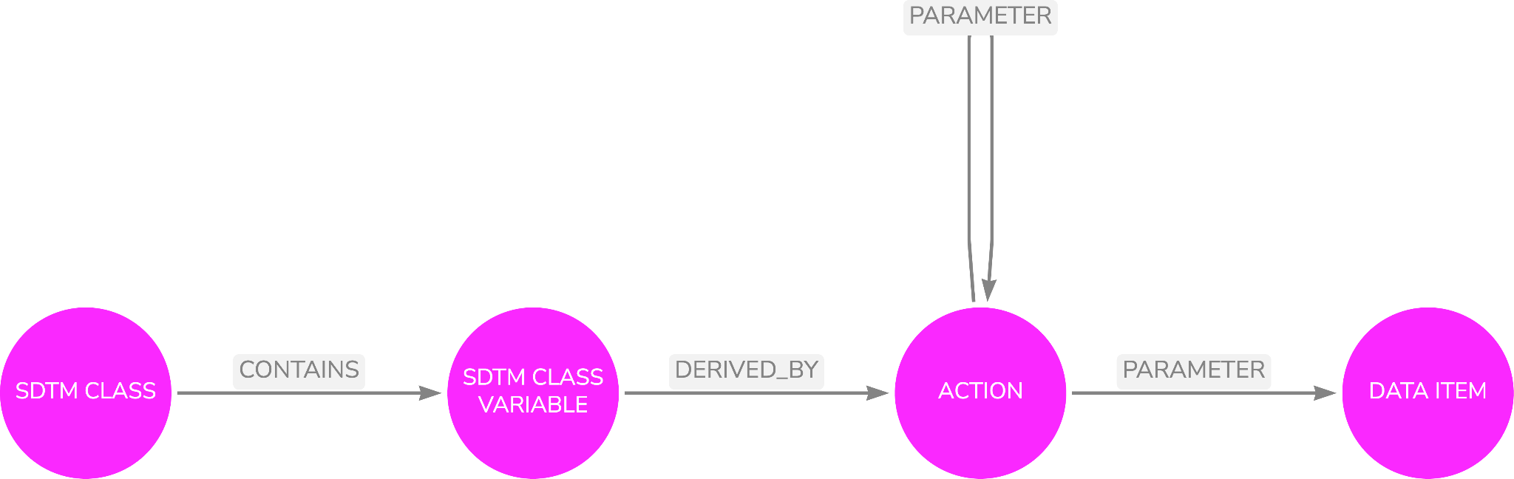

Figure - Action Logic

An action contains a single method that is executed with parameters. The parameters are either an item of data or the result of another action. This recursive structure can be used to build any logic using any set of methods. The methods themselves can be provided in any programming language such as python or R.

## Prototype Notes

### Core Data

The prototype includes data for the following domains

1. Vital Signs
2. Exposure
3. Adverse Events
4. Demographics

The outputs from the query are very vertical in nature; they are value name pairs for variable names and value with the associated study design information for the relevant data point. Each data point can be identified via the biomedical concept and thus the data for the BC can be associated with each other thus a row of SDTM can be formed.

The dashboard allows for the domain to be selected and the data for the domain to be displayed.

### Derived Data

Some work has been undertaken to show the operation of derived variables and how the model-based approach described above can be used to derive data within SDTM. --DY has been used for this. The concept is sound but a little more work is needed.

### Next Steps

The following issues need to be looked at:

1. It is a long term aim to extract the SDTM Trial Design Domains from the model but this has not been done as yet.
2. We need to demonstrate the use of Supplemental Qualifiers. A design has been developed but it needs to be documented within this document and tested within the prototype.
3. The mix of BCs and single questions needs to be considered. A design is available Questions but it needs to be documented within this document and tested within the prototype.

## Issues

None currently

## Summary

The addition of the data into the graph completes the picture providing a single knowledge graph containing the study design with a precise definition of data needs, the study data, and links to operational standards such that the automation of the necessary submission artefacts can be achieved.

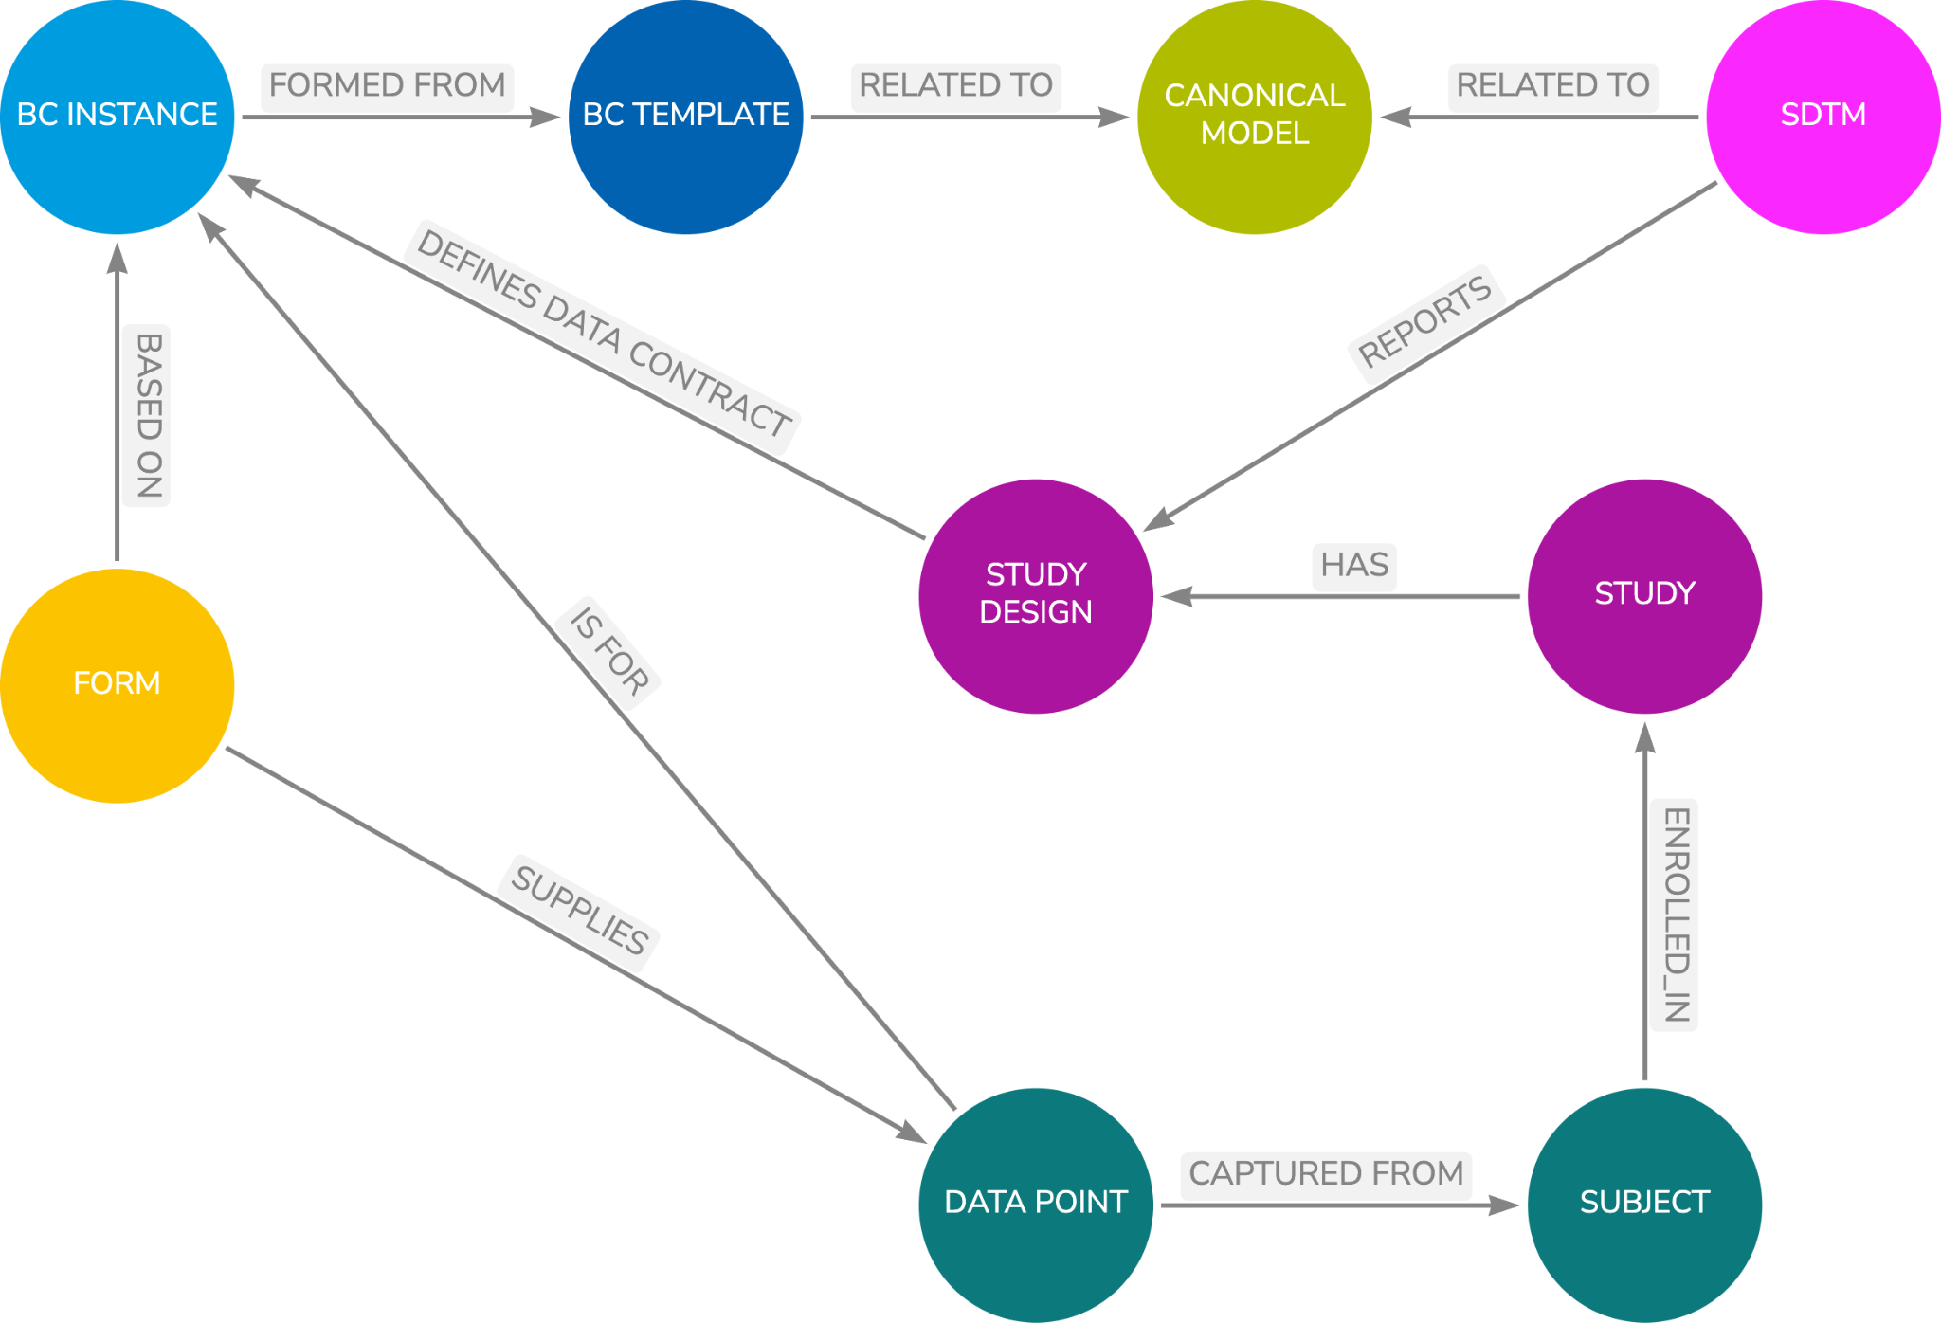

Figure - Model Overview

In summary

1. Link the data to the design to provide a single coherent and consistent view of a study and the data
2. Query for the raw data and associated study design references
3. Generate the derived data either by processing the skeleton domains outside of the graph using traditional mechanisms (which could be standardised) or using a graph approach to store the logic which can then be executed.

# Other Data Imports and Exports

## Overview

This chapter will discuss how other clinical data models can use the Canonical Model to link to the model and thus data can be imported from sources such as wearables, medical devices, and Electronic Health Records (EHRs) and exported to other systems for the purposes of data sharing.

Potential import source standards include:

1. FHIR
2. OpenEHR
3. OMOP
4. Others TBD

Potential export destinations include:

1. OMOP
2. Others TBD

Within the current issue of the document only FHIR is covered.

## FHIR

### Approach

The approach taken with FHIR is to build a small model that details the structure of FHIR resources (those of interest, not all) down to and including the FHIR data types and the associated data type properties. Given that the Canonical model uses the FHIR data types, and this is one of the reasons for using them, there is therefore a direct link between the leaf nodes of the FHIR resource model and the leaf nodes of the Canonical model due to this use of the common data types.

Using the data types, it is possible then to link the FHIR model to the Canonical model and thus the FHIR model is connected to the remainder of the knowledge graph.



Figure - Linking FHIR

*Since the initial prototype work was performed it has been discovered that HL7 have developed an OWL model of FHIR resources [8]. This would be an ideal model to use and link to the canonical model.*

Having the model in place now allows any data held in a FHIR resource structure to be added to the study if there is an appropriate path linking a BC field to a FHIR resource field.

The model can then be employed in a variety of use cases depending on requirements.

Consider the case where we have a form composed of a BC. Data for the form can be acquired by using the embedded definition of the BC to obtain the identifier and qualifier properties required to convert to a LOINC code. This is because CDISC test codes do not map directly to the LOINC codes, a LOINC code generally equates to a CDISC test code plus fixed qualifiers.

For example, LOINC 8460-8 is systolic blood pressure--standing while 8459-0 is systolic blood pressure--sitting. It is possible to expand the BC definition to allow for the LOINC code or codes to be part of the BC definition such that these can be easily mapped in either direction, CDISC to LOINC or LOINC to CDISC.

With a LOINC code available, a request can be sent to an EHR for any data for a specific subject for that LOINC code. A FHIR response is received and the data within the resource returned can be mapped to the BC and the data added to a study for the correct subject.

Picking which data are to be used is usually the bigger problem. What time window should I select, which visit does it belong in, the questions are many but fall outside of the scope of this paper, but it is a tricky issue.

There are also issues with unit conversions (for example UCUM to CDISC) and potential terminology mappings with qualifiers (code list mappings) but these will be encountered with whatever mechanisms are used to acquire the FHIR data. The unit conversion is relatively straightforward to solve, there are APIs which will perform such conversions, but the terminology mapping problem is less easy to solve; we need mapping tables.

### Prototype Notes

### General

Within the prototype a simple example has been included to show the principles. The example needs to be expanded to become comprehensive, but the key principles are demonstrated.

The prototype includes:

1. The loading of the FHIR model
2. The FHIR model is linked to the canonical model
3. A request for a patient/subject weight is made to an EHR API of synthetic data from an EHR hosted in the cloud
4. The response is returned
5. The model is then used to determine the fields to extract from the resource based on a BC. This query determines which bits of the resource to extract.
6. The data are then added into the study. Currently uses a fixed visit.
7. The VS domain is then queried to show the data are present for the subject in question

### Next Steps

Next Steps include:

1. Expand the FHIR model
2. Add in unit conversions
3. LOINC CDISC mapping

## openEHR

Not covered in this issue.

## OMOP

Not covered in this issue

## Issues

The following needs to be considered:

1. Methods for determining where the data received from external sources should be placed within the context of a study. This is normally harder than the technical aspects of accessing the data
2. Privacy, access rights and security are not considered within scope of this paper.

## Summary

The creation of a FHIR model linked to the canonical model brings great power to easily incorporate EHR data (or any other source using FHIR) into a clinical research framework. The power derives from the Canonical model and the ability to align models. The figure below shows the knowledge graph as it grows linking disparate worlds into one coherent view

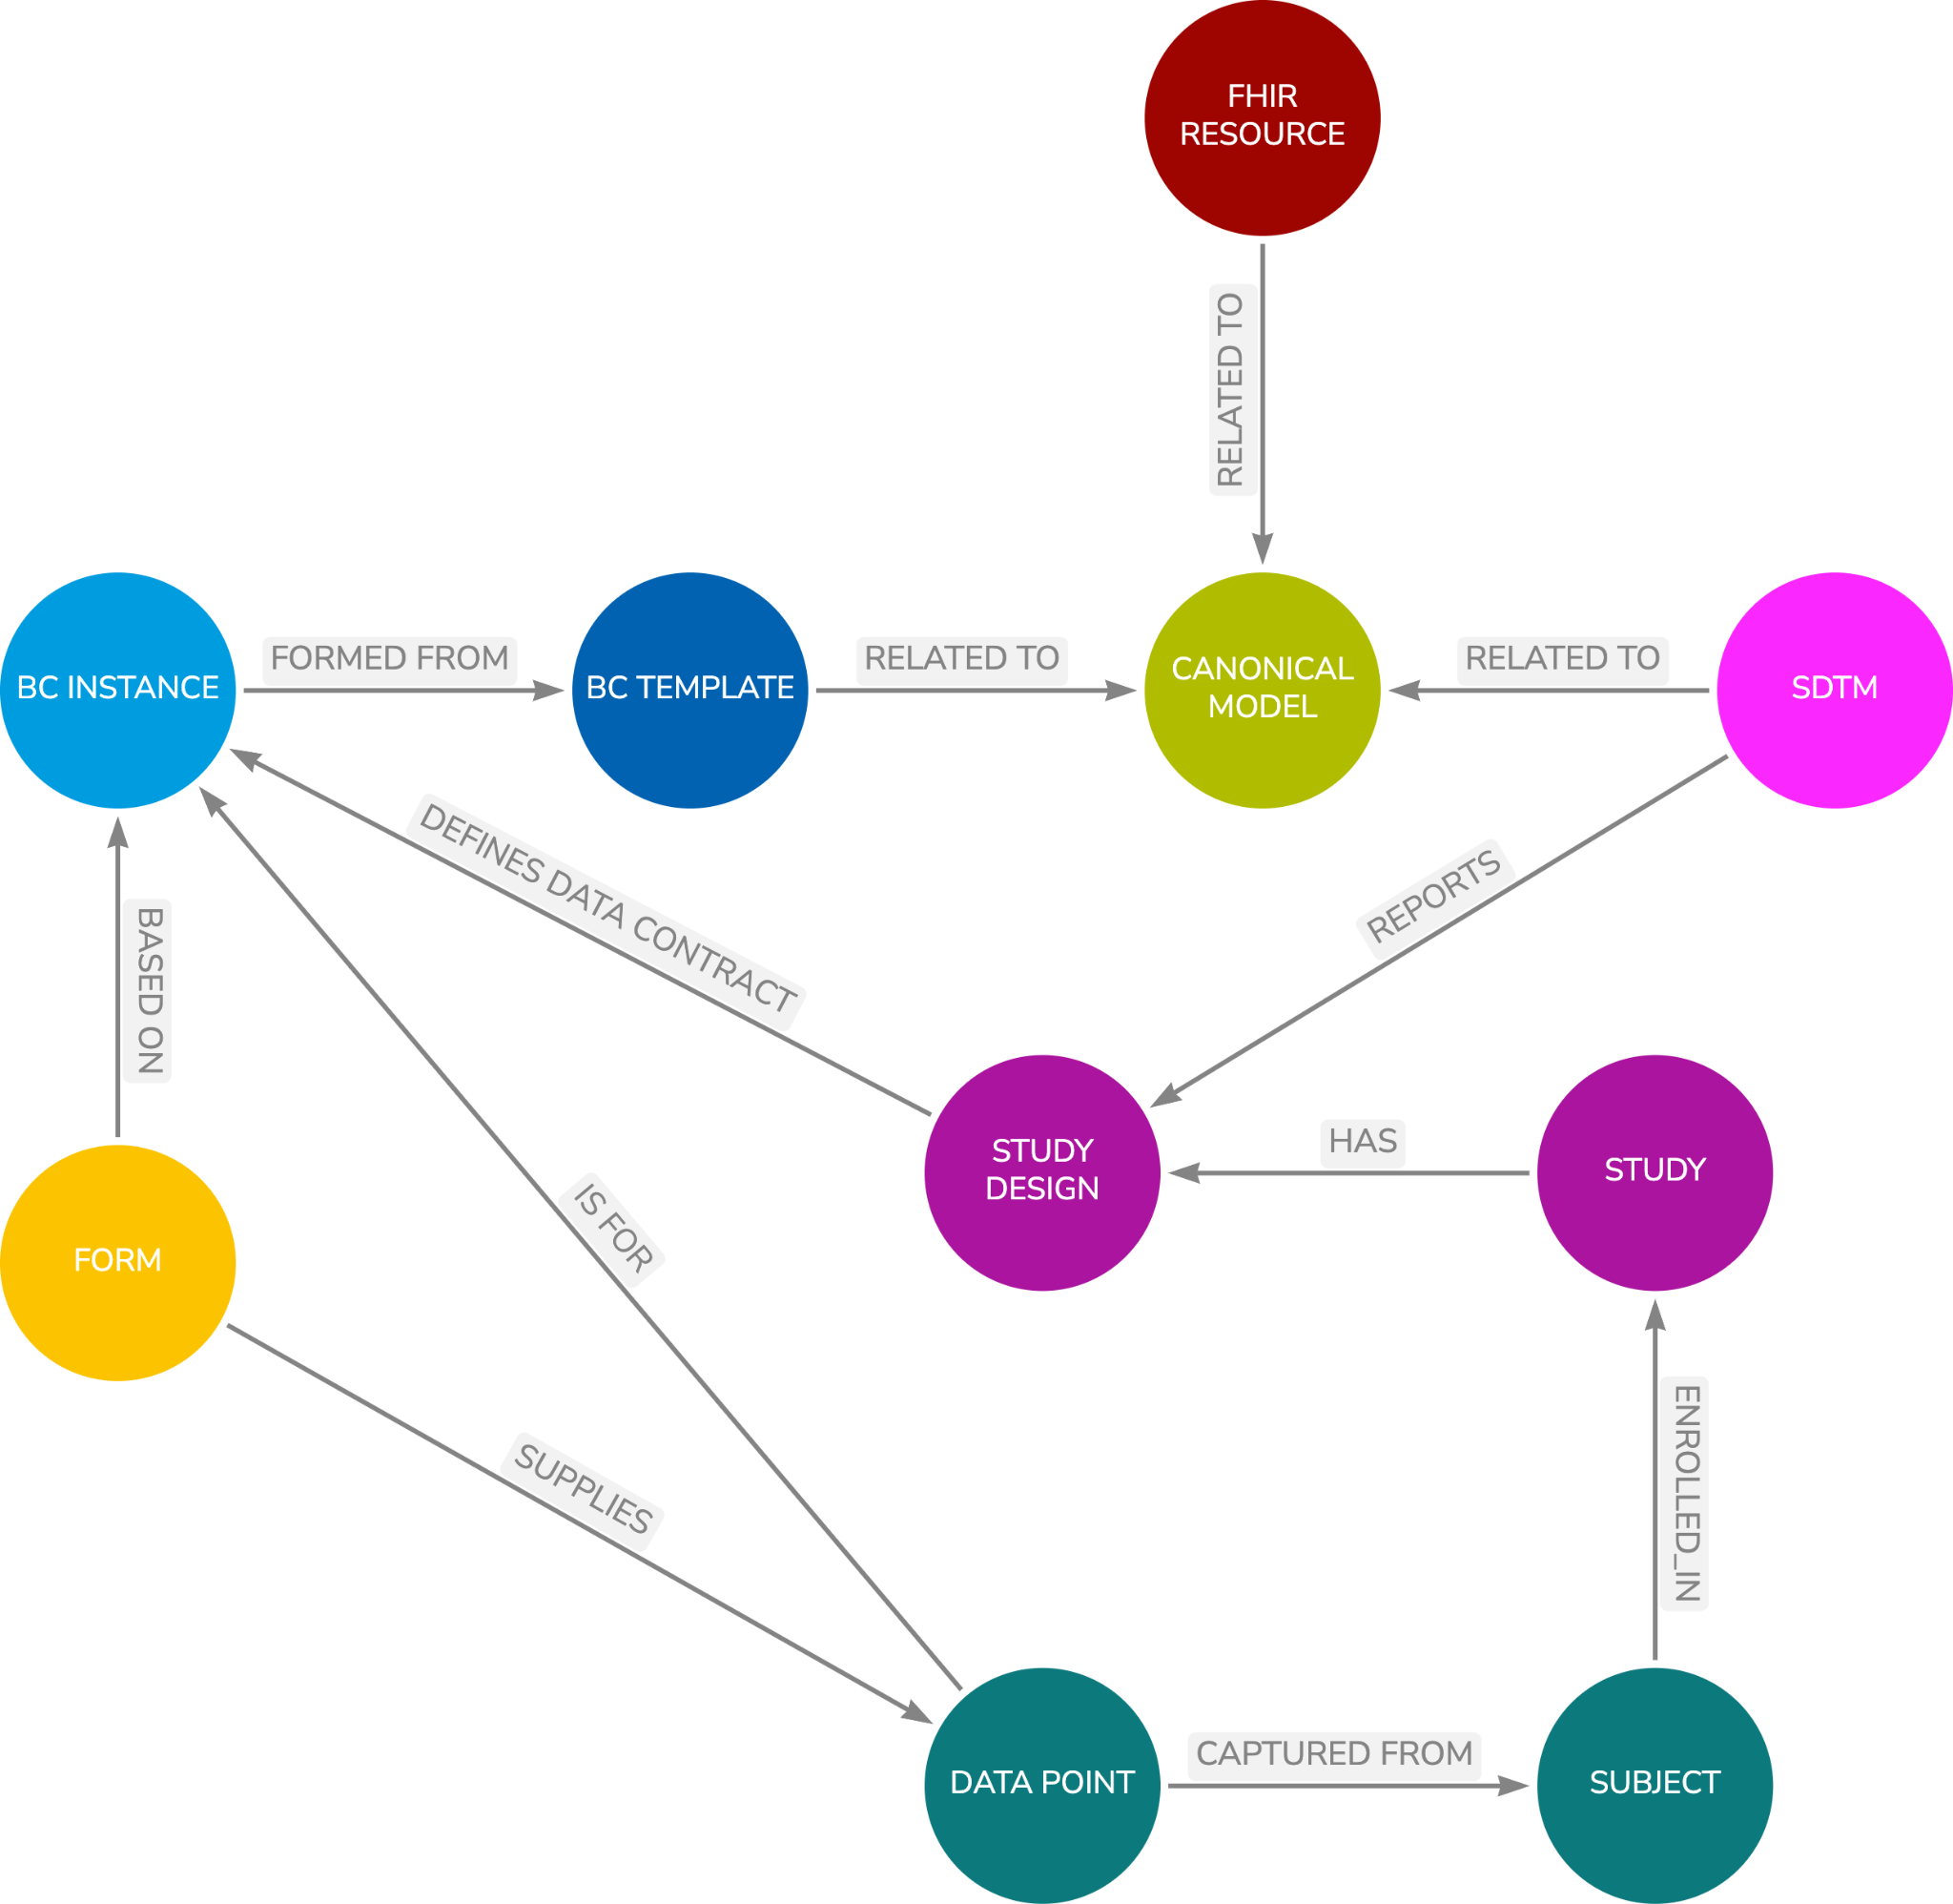

Figure - Model Overview

# Study aCRF and Define.xml

## Overview

This chapter details how a study annotated Case Report Form and Define.xml can be generated from a study definition that is based on BCs.

Practical experience has shown this can be achieved without much effort from a well organised set of [meta]data that links the Study Design and the associated Data Contract, and how the Data Contract was fulfilled. This combined data can then be automatically presented as an aCRF and define.xml.

# Tabular Structures

## Overview

This chapter will discuss the use of the Canonical Model with other tabular structures and not just SDTM. Other tabular models can be supported thus allowing flexibility going forward such as SDTM flavours or tailored datasets such as the FDA BIMO site inspection datasets.

# BC Mining

## Overview

This chapter will discuss how the vast bulk of BCs can be created from existing sources without involving a massive creation exercise.

# Formal Definition

## Overview

This chapter will detail the formal definition of BCs. openEHR uses a formal definition language, Archetype Definition Language (ADL), for expressing archetypes. This chapter will discuss the need for such with BCs using an RDF and SHACL approach.

# The Future and Next Steps

## Overview

This chapter will cover any other topics that arise from writing this document.

# References

[1] STUDY DATA TECHNICAL CONFORMANCE GUIDE, FDA, February 2014  
  
 *Note that the current version of the guide is v4.8.1 dated October 2021.*

[*https://www.fda.gov/media/153632/download*](https://www.fda.gov/media/153632/download)

[2] RG06 – It’s Time to Change, PhUSE US Connect, 2018

<https://www.lexjansen.com/phuse-us/2018/rg/RG06.pdf>

[3] Blog: Thoughts on Medical Informatics, Armando Oliva M.D.

<https://aolivamd.blogspot.com/>

[4] Into the Fire, Linking CDISC & FHIR, PhUSE EU Connect, 2018

<https://www.lexjansen.com/phuse/2018/si/SI12.pdf>

[5] FHIR data types

<http://hl7.org/fhir/datatypes.html#2.24.0>

[6] SI13 - Removing Silos: Placing Data at the Centre, PhUSE US Connect, 2019

<https://www.lexjansen.com/phuse-us/2019/si/SI13.pdf>

[7] Digital Data Flow Solution Framework and Conceptual Design Version 1.0,

Dated 1 November 2019, Appendix A

[8] HL7 FHIR OWL model <https://www.hl7.org/fhir/fhir.ttl>